

A Sample Engagement Process for Implementing a Web Site

Design Stage

Table of Contents
Business and Creative Workstream Overview 6
Content Workstream Overview 7
Organizational Readiness Workstream Overview 8
Technology Workstream Overview 9
Testing Workstream Overview 10
Design Stage 11
Business and Creative Design Stage Overview 12
Creative Treatments & Concepts 13
Overview 13
Creative Concept – Examples 14
Web Page and Graphics Layout Finalization 15
Overview 15
Sample Work Product 16
HTML Development 17
Overview 17
Sample Work Product 18
Content Stage Overview 19
Categorization Hierarchy & Content Types 20
Overview 20
Sample Work Product 21
Content Migration Process 22
Overview 22
Sample Work Product 23
ERM Classifiers/Qualifiers/Channels 24
Overview 24
Sample Work Product 25
Content Attributes (Metadata) 26
Overview 26
Sample Work Product – Content Ad Attributes 27
Sample Work Product – Content Editorial Attributes 28
Sample Work Product – Content Product Attributes 29
Content Authors, Roles and Workflow 30
Overview 30
Sample Work Product – Authors and Roles 31
Sample Work Product – Publishing Flows 32
Sample Work Product – Workflows 33
Content Management Templates 34
Overview 34
Sample Work Product 35
Organizational Readiness Stage Overview 36
Organizational Readiness New Structure 37
Overview 37
Sample Work Product – Organizational Readiness Org. Chart 38
Sample Work Product – Organizational Readiness Unit Relationship 39
Organizational Readiness Job Profiles 40
Overview 40
Sample Work Product 41
Organizational Readiness Hiring Requirements 42
Overview 42
Sample Work Product 43
Organizational Readiness Training Program 44
Overview 44
Sample Work Product – Training Programs 45
Sample Work Product – Training Schedule 46
Organizational Readiness Changes and New Processes 47
Overview 47
Sample Work Product 48
Organizational Readiness New Processes 49
Overview 49
Sample Work Product – Process Symbols 50
Sample Work Product - Process Flow Diagram 51
Sample Work Product - Process Cross-Reference 53
Sample Work Product - Input/Output Description Template 55
Technology Overview 56
Web Page Program Design Overview 57
Java/C++ Custom Component Design 58
Overview 58
Sample Work Product 60
Sample Work Product - Fleet Schema 62
Sample Work Product - Common Component Functions 70
Design JavaScript Utility / Startup Functions 72
Overview 72
Sample Work Product 73
Sample Working Document - Development Environment Guide 77
Sample Work Document - Scripting Guidelines 85
Identify Common Components 95
Overview 95
Sample Work Product 96
1.1. Purpose 98
1.2. Page Layout 98
1.3. Page Definition 98
1.4. Session Information 98
1.5. Edit/Validation Specification 99
1.6. Object Event Description 99
1.7. Page Logic Specifications: Pseudo Code 99
1.8. Exception Handling (Errors/Recovery) 100
1.9. Components Required 100
1.9.1. Interface Components 100
1.9.2. One-to-One Components 101
1.9.3. New Components required (GAP design reference) 101
1.10 Other Dependencies 101
1.11 Issues 101
1.8. Purpose 103
1.9. Page Layout 103
1.10. Page Definition 103
1.11. Session Information 103
1.12. Edit/Validation Specification 104
1.13. Object Event Description 104
1.14. Page Logic Specifications: Pseudo Code 104
1.8. Exception Handling (Errors/Recovery) 105
1.9. Components Required 105
1.9.4. Interface Components 105
1.9.5. One-to-One Components 106
1.9.6. New Components required (GAP design reference) 106
1.10 Other Dependencies 106
1.11 Issues 106
1.15. Purpose 108
1.16. Page Layout 108
1.17. Page Definition 108
1.18. Session Information 108
1.19. Edit/Validation Specification 109
1.20. Object Event Description 109
1.21. Page Logic Specifications: Pseudo Code 109
1.8. Exception Handling (Errors/Recovery) 111
1.9. Components Required 111
1.9.7. Interface Components 111
1.9.8. One-to-One Components 111
1.9.9. New Components required (GAP design reference) 112
1.10 Other Dependencies 112
1.11 Issues 112
Design of Individual JavaScript Pages 113
Overview 113
Sample Work Product 114
Sample Work Document - Blank Detailed Design Template 119
Data Architecture Overview 123
Determine the Additional Attributes Required for Personalization 124
Overview 124
Sample Work Product 125
Determine the Additional Attributes Required for Performance 126
Overview 126
Sample Work Product 127
Review Any New Content Types Required for BroadVision Schema 128
Overview 128
Sample Work Product 129
Design Physical BroadVision Data Model 130
Overview 130
Sample Work Product 131
Develop Data Dictionary – (Optional) 133
Overview 133
Sample Work Product 137
Design BroadVision Schema for External Data Sources 138
Overview 138
Sample Work Product 139
Technical Infrastructure Overview 140
Prepare IT Environment Build-out 141
Overview 141
Sample Work Product 142
2.0 Construct and Implement Development Operations and Management Environment 142
Construct and Implement Development Site Networks 144
Overview 144
Sample Work Product 146
Construct and Implement Development Operations and Management Environment 147
Overview 147
Sample Work Product 149
Install and Configure IT Development Environment Components 150
Overview 150
Sample Work Product 152
Test IT Development Environment 153
Overview 153
Sample Work Product 154
Submit IT Environment 155
Overview 155
Technology Interface / Batch / Data Migration Design Overview 156
Define Translation Rules for each Data Element 157
Overview 157
Sample Work Product 158
Define Error Identification and Cleansing Strategies 159
Overview 159
Sample Work Product 160
Define Audit Trails Necessary for Proof of Running 161
Overview 161
Sample Work Product 162
Define Reconciliation Strategy 163
Overview 163
Sample Work Product 164
Define Recovery and Restart Procedures 165
Overview 165
Sample Work Product 166
Define Recovery and Restart Procedures 166
Define Rerun Procedures 167
Overview 167
Sample Work Product 168
Reporting Design Overview 169
Report Design 170
Overview 170
Sample Work Product 171
Testing Design Overview 173

Business and Creative Workstream Overview
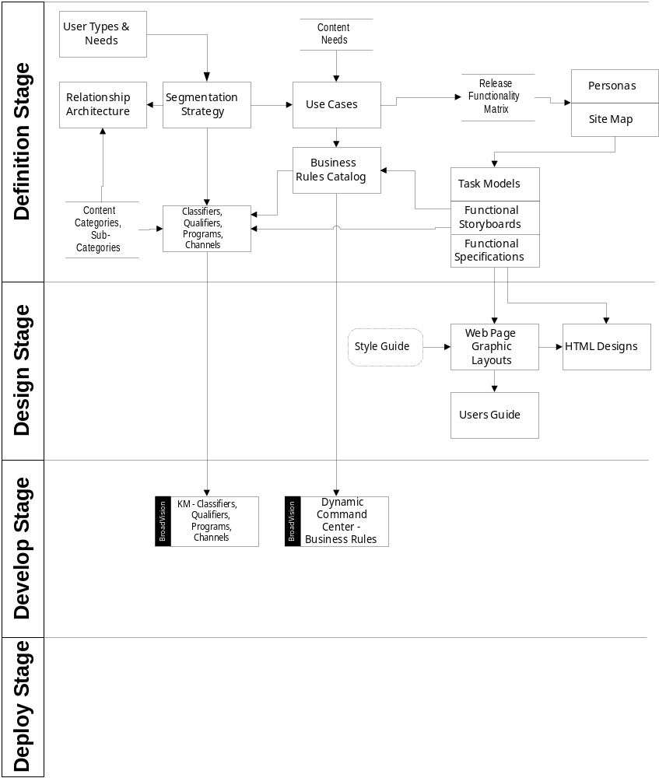

Content Workstream Overview
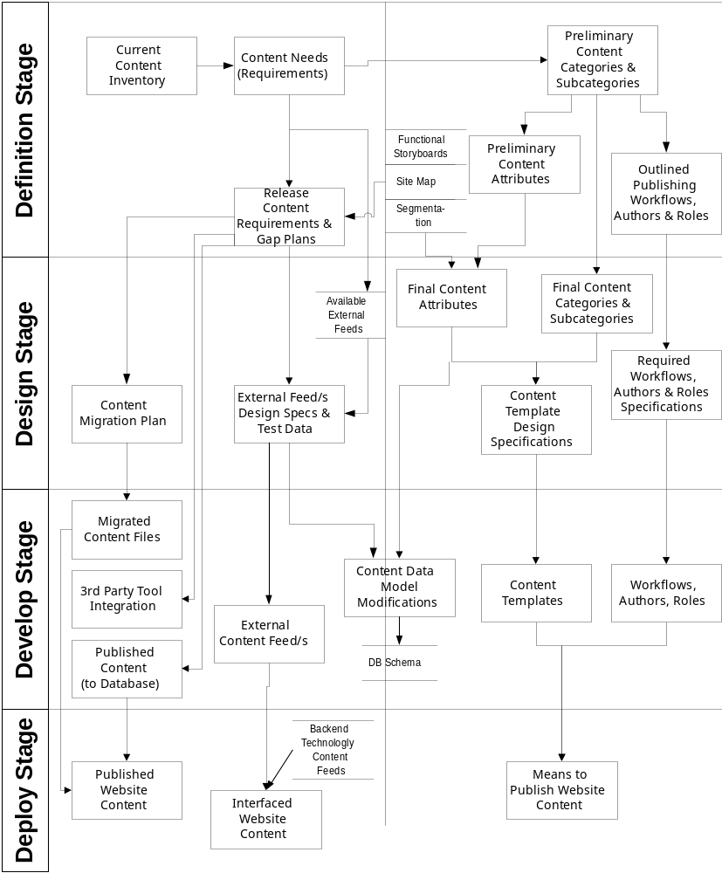

Organizational Readiness Workstream Overview
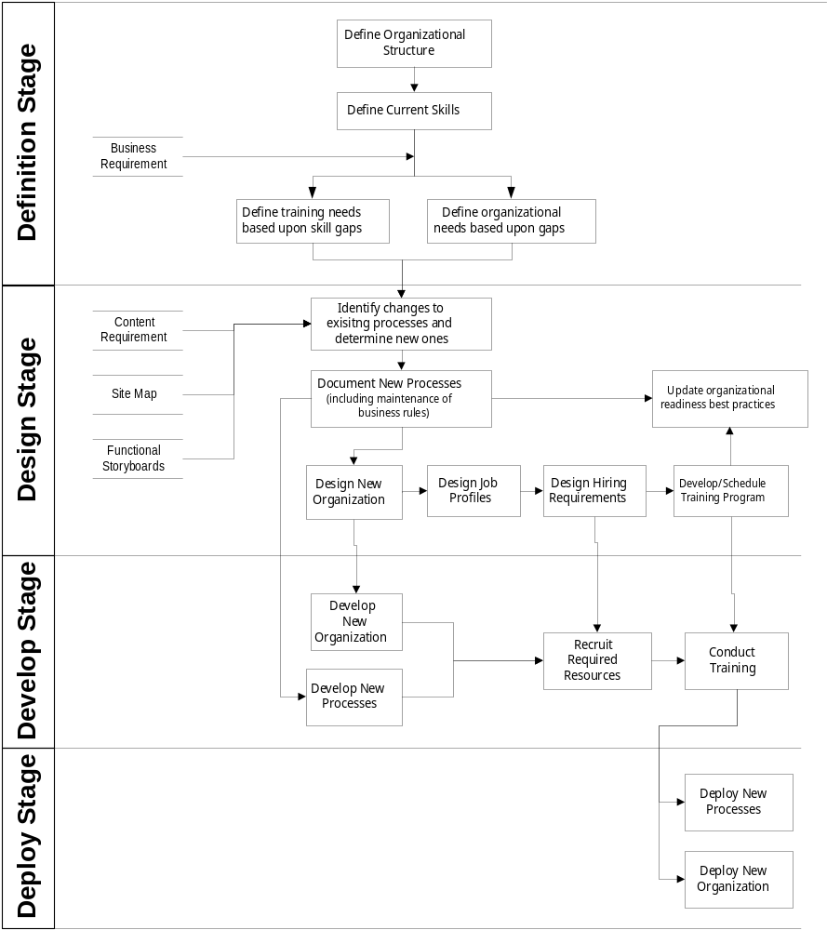

Technology Workstream Overview
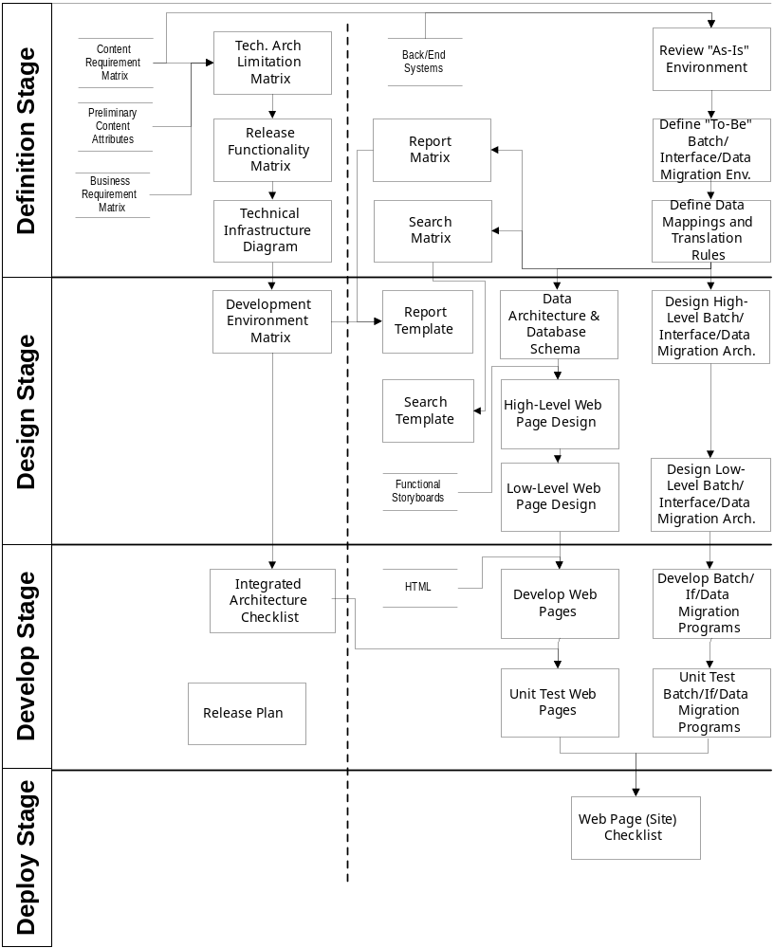

Testing Workstream Overview
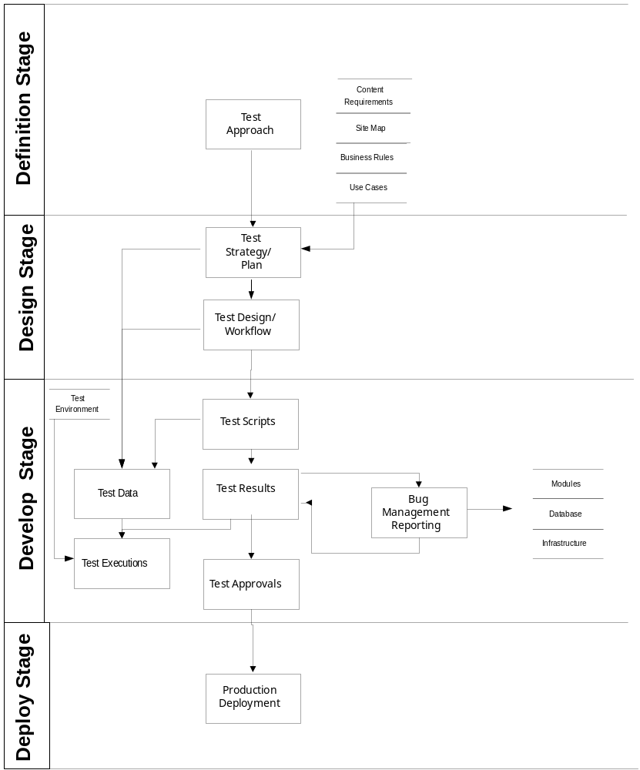

Design Stage

1 - Business and Creative
A - Creative Treatment Alternatives
B - Web Page and Graphics Layout Finalization
C - HTML Development

2 - Content
A - Content Categorization Hierarchy
B - Content Migration Process
C - Identify External Feeds and Interface Requirements
D - Attributes (metadata)
E - Authors, Roles and Workflow
F - Content Management Templates

3 - Organizational Readiness
A - New Organizational Structure
B - Job Profiles
C - Hiring Requirements
D - Schedule Training Programs
E - Identify Changes and New Processes
F - Document New Processes

4 - Technology
A - Web Page Program
B - Data Architecture Design
C - Technology Infrastructure Diagram
D - Interface-Batch-Date Migration
E - Reporting Design

5 - Testing

Business and Creative Design Stage Overview

Update style guide

Finalize web page and graphics layout
Design creative treatment alternatives

Develop HTML
Update best practices and creative guides

Creative Treatments & Concepts

Overview | The creative treatment process involves a high level of creativity from the design team. With input from the users, the objective now is to stretch the creative limits of that box without breaking it. With the design parameters already in place the designers can begin putting together the treatments and concepts that will ultimately led to the final "look and feel" of the site. The client can expect to see a variety of ideas here.

Approach | The process involves the development of full color rendering suggesting final “look and feel”. This process is normally performed in one of two ways:  - The design team generates a variety of creative concepts that best represents the client needs based on the designated design parameters.  - The design team not only expands on the creative ideas that are found on the existing site, but also infuses new ideas to ensure the freshness of the "look and feel".  No matter the approach, multiple treatments are submitted for client review.

Work Product | A creative treatment is typically a Photoshop mock-up of the web page layout, to define colors, images or a 'user experience'.

Sample Work Product | See Example_Creative_Concept_1_01.pdf (example 1).  See Example_Creative_Concept_1_02.pdf (example 2).  See Example_Creative_Concept_1_03.pdf (example 3).  See Example_Creative_Concept_1_04.pdf (example 4).  See Example_Creative_Concept_1_05.pdf (example 5).

Creative Concept – Examples

Web Page and Graphics Layout Finalization

Overview | Working through the best of the ideas that have been presented, the user team  selects master treatments in order to establish the overall "look and feel." At this point the creative team can begin the design and apply this treatment to both the static and dynamic HTML templates.

Approach | The web page and graphics layout finalization is an iterative refinement process. The design team works closely with the user team to mix and match elements and build consensus toward one design. The ultimate goal of the exercise is to gain client approval of the master treatment and generate templates in order to establish the cornerstone for all subsequent HTML generation.

Work Product | The work product is typically a Photoshop mock-up of multiple HTML templates for both the static and dynamic templates.

Sample Work Product

Sample Work Product
TBD

HTML Development

Overview | This step of the design is comprised of the HTML development for both the static and dynamic pages. This is the first step that begins to bridge the gap between the "look and feel" of the site and the functionality of the site. The development of the HTML is heavily dependent upon the preceding steps as input into the process. The functional storyboards, "elected" creative treatment and the finalized web page/graphics layout are the key inputs into this process.

Approach | The output from the web page finalization will serve as the primary input into the HTML generation (e.g., PhotoShop files). Portions of graphics and elements will be extracted from the Photoshop files and entered in the HTML generation tool. Once completed the dynamic HTML templates will be handed off to the BroadVision JavaScript developers to continue with the design and construction of the dynamic content. The static HTML will be considered complete at the end of this step.

Work Product | The output to this process is the HTML file typically created using an HTML generation tool (e.g. Dreamweaver, etc).

Sample Work Product

Sample Work Product
TBD

Content Stage Overview

Design content types, attributes (metadata)
Design content management templates
Design authors, roles and workflows
Design content migration process
Design categorization hierarchy
Identify external feeds & interfaces requirements

Categorization Hierarchy & Content Types

Overview | The content types and categorizations identify how content will be organized at the highest level. This analysis is performed after the user content needs analysis. The analysis is the logical grouping of the existing content needs and this categorization eventually will serve as the content hierarchy.

Approach | The approach to obtaining the content categorization is to work through the user content needs list and to “bucketize” or group related needs into logical categories and sub-categories. Doing this should also take into account how rules will be targeted and implemented against content.  The approach to obtaining the content types as a rule should generally utilize the BroadVision out-of-the-box content types (editorials, products, advertisements, etc.) unless special access rights are needed to utilize the One-To-One Command Center.

Work Product | The typical working document is a matrix form managed in a MS Excel worksheet that provides ease of manageability and organization. The needs list is also cross-referenced to the categories by adding an additional column to the needs list which holds the related category/subcategory. The user content needs list will be organized by content type, categories and subcategories.

Input | Preliminary categorization based on content needs, wireframes, preliminary site map/flow, preliminary business rule list, user segementation and client personnel who are familiar with existing content and site personalization strategy.

See following pages for Content Categorization.

Sample Work Product
Content Categorizations | Content Type
- News & Information  - National Headlines  - International Headlines  - Regional/Local Headlines  - Industry Specific  - Weather  - Travel  - Airfare  - Hotel  - Ca Rental  - Stocks  - Currency Exchange Rates  - Economic Trends & Forecasts | Editorial

Content Migration Process

Overview | The content migration requirements identify the steps needed to migrate content from the current content environment into the BroadVision system. This analysis is performed after the content inventory and user content needs exercise. The information can be identified either in a separate content migration requirements document or simply as additional column headers on the content inventory matrix. Migration requirements may be identified on an item-by-item basis or on small groups of related items at a topic basis.

Approach | The approach to obtaining content migration requirements is primarily achieved through working through the content inventory and identifying the different types of content that need to be integrated into the BroadVision system. Different types of content may require varying levels of migration effort. This can include external content feeds, existing static content, existing dynamic content, etc. The migration process should identify what level of migration effort will be targeted for these different content items/groups.

Work Product | The typical working document is prepared and managed in an MS Excel worksheet in a matrix form that provides for ease of manageability and organization. Typically, the content migration requirements document contains headers such as complexity, migration method and potential migration issues.

Input | Completed content inventory and client personnel who are familiar with existing content and architecture.

See following pages for Content Migration plan.

Sample Work Product

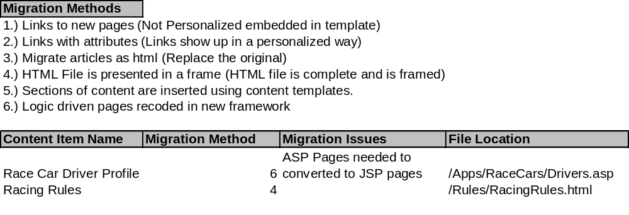

ERM Classifiers/Qualifiers/Channels

Overview

Approach

Work Product

Input

See following pages for …

Sample Work Product

Content Attributes (Metadata)

Overview | Content attributes provide information about content that help determine its relevancy to a user. This information, or meta-data, are descriptors of content and can include data information (creation date, start date, end date, title, text, etc.) and matching information (industry, segment, etc.). This information is used to identify content records so that they may be dynamically served to a user based on the matching of a business rule against the content attribute(s).

Approach | The approach to obtaining content attributes is to identify how content will be used on the site to satisfy particular user’s needs. Doing this should also take into account the different ways content will be served throughout the site. This also may take into account the different business rules that will be implemented to ensure that the appropriate attributes are identified to satisfy these rules.

Work Product | The typical working documents are matrices based on content type such as editorial, products and advertisements that break out attributes for each content category and subcategory as identified in the content categorization. This document is prepared and managed in an MS Excel worksheet in a matrix form that provides for ease of manageability and organization. Typical column headers include content category, subcategories, attributes and related attributes.

Input | Completed content categorization, user segments, wireframes, preliminary site map/flow, preliminary business rule list and client personnel who are familiar with existing content and site personalization strategy.

See following pages for the advertisements, editorials, products, incentives, discussion groups, templates and custom attributes.

Sample Work Product – Content Ad Attributes
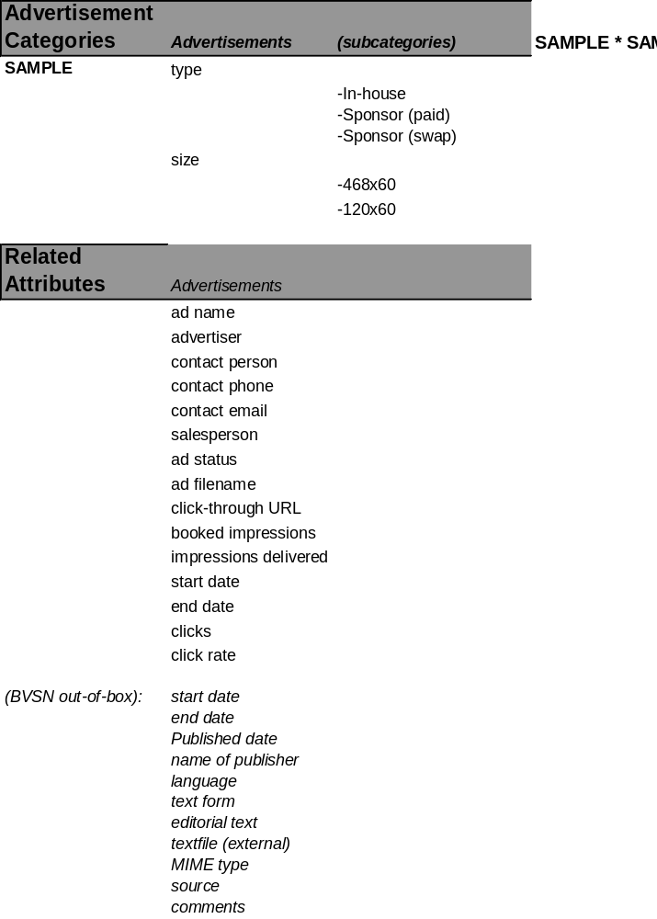

Sample Work Product – Content Editorial Attributes
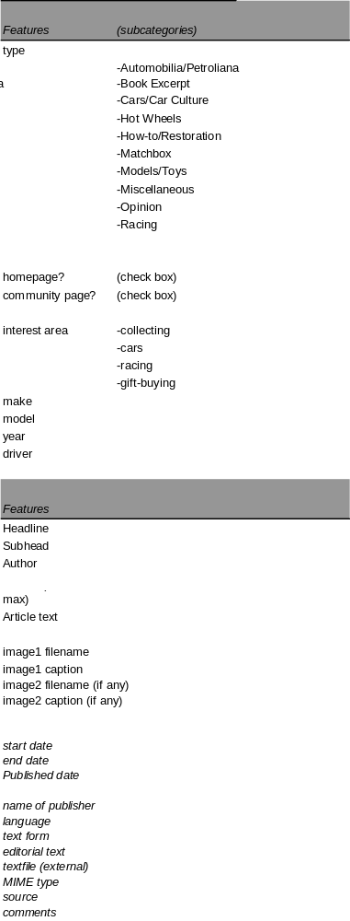

Sample Work Product – Content Product Attributes
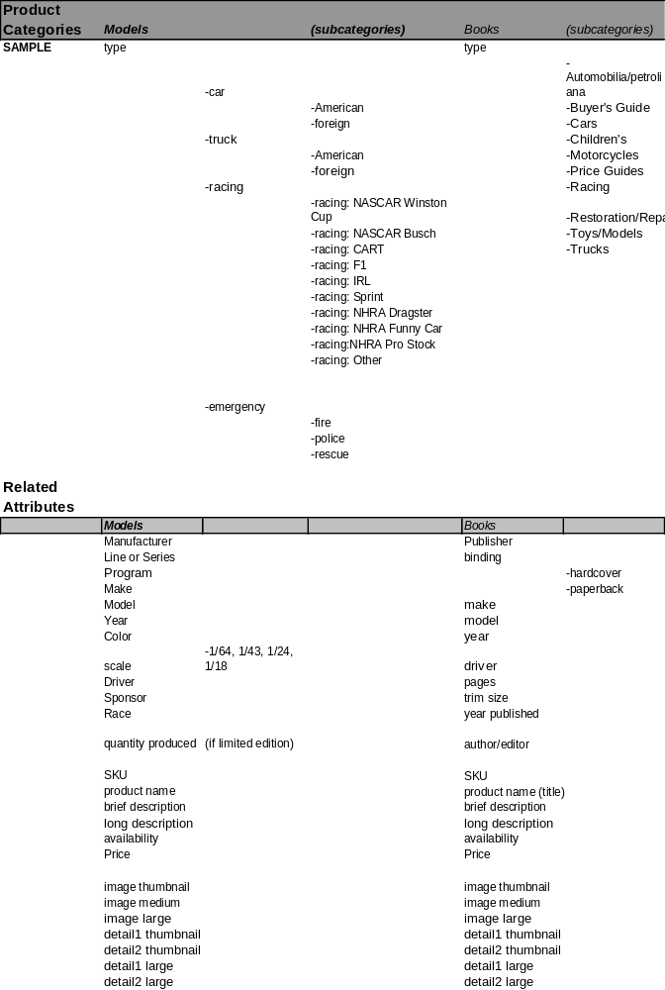

Content Authors, Roles and Workflow

Overview | Authors, roles and workflow provide the information necessary to determine the individuals responsible for creating, tagging and approving content within the BroadVision system. This exercise also determines the responsibilities of each individual involved as well as the overall process used to track and edit content from creation to publishing.

Approach | The approach to identifying authors, roles and workflow is to identify the different processes needed for creating, tagging and approving content within the organization as well as the individuals involved and their roles within the process. Once a set of standard workflows are identified, each category is mapped to a specific workflow that will be used to publish that type content. Often, one workflow will apply to many different categories. For example, certain content categories may require legal approval prior to publishing. In this case, a separate workflow will be needed to account for this step in the approval process. These workflows are often based upon existing workflows within the organization that are translated into the publishing environment.

Work Product | The typical working document is a set of matrices and diagrams that identify the authors, roles and workflow associated for different content categories requiring separate workflow processes. This document is prepared and managed in an MS Excel worksheet in a matrix form that provides for ease of manageability and organization. The typical column headers that identify this information include workflow name, state name, access group, description, start state, next state and attribute assigned.

Input | Completed content categorization and client personnel who are familiar with existing content and workflow processes.

See following pages for Authors, Roles and Workflow Matrix.

Sample Work Product – Authors and Roles



Sample Work Product – Publishing Flows
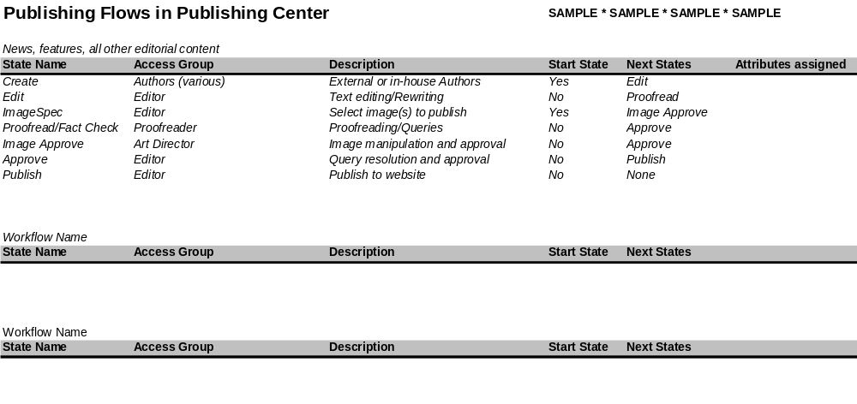

Sample Work Product – Workflows

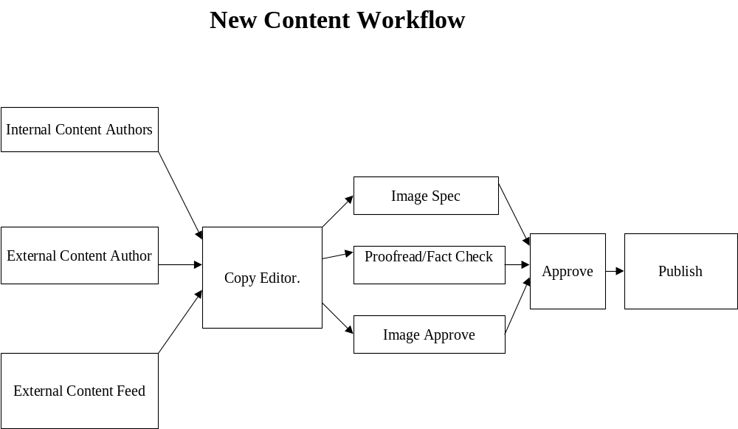

Content Management Templates

Overview | Content templates provide the information necessary to create, tag and submit content with the appropriate attributes into the BroadVision system. These templates provide an easy mechanism for various and distributed content creators and editors to create, tag and submit content.

Approach | The approach to identifying content templates is to examine the types (and categories) of content that will be published on a frequent basis into the BroadVision system. To ensure the appropriate information is published into the system, the templates must include the attributes for the content category. These attributes become the fields that content creators and editors use to create, tag and submit content. These fields can be text fields, radio buttons, drop-down boxes, etc. to facilitate efficient and consistent content publishing.

Work Product | The typical working document is a matrix based on content categories that break out attributes and corresponding attribute values. This document is prepared and managed in an MS Excel worksheet in a matrix form that provides for ease of manageability and organization. Typical column headers include content category, subcategories, attributes, related attributes, and corresponding attribute values.

Input | Completed content attributes and client personnel who are familiar with existing content and site personalization strategy.

See following page for Content Templates Matrix.

Sample Work Product
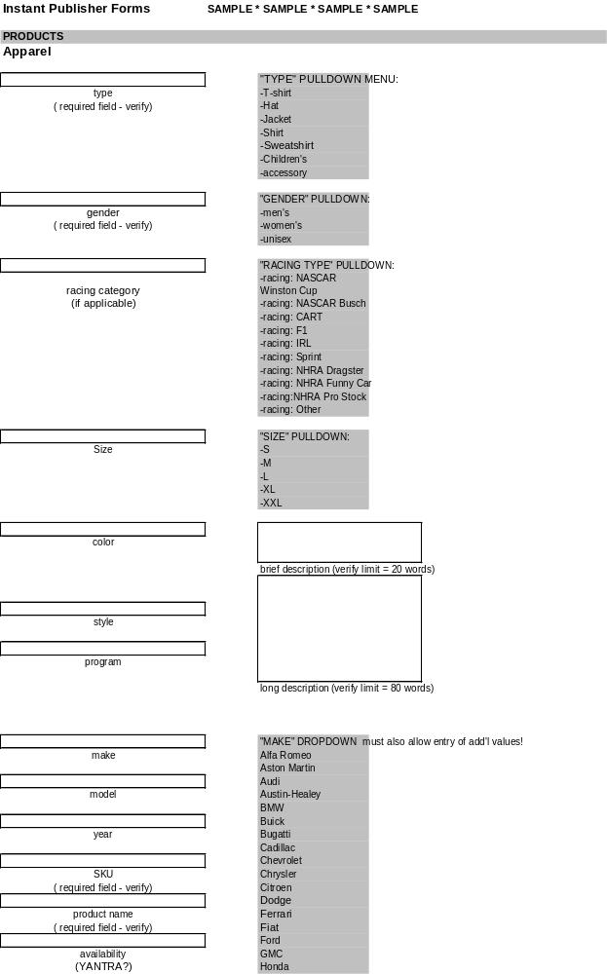

Organizational Readiness Stage Overview

Design new organization
Identify changes to existing processes and determine new ones

Develop job profiles
Document new processes (including maintenance of business rules)

Develop hiring requirements

Schedule training programs

Update organizational readiness best practices

Organizational Readiness New Structure

Overview | A new web technology will normally have an impact on the structure of the organization. As process changes are defined for maintaining dynamic personalized content, new roles and responsibilities are identified, information on the impact to the organization structure must be gathered. A new structure is designed to account for process changes and new roles and responsibilities.

Approach | The approach to designing organization structure is to identify the necessary activities. Then create a logical grouping of theses activities in an appropriate hierarchy. Next, prepare a description of all the various relationships.

Work Product | The typical working document will be an organization chart indicating the relationships between divisions, units, groups, and/or individuals. This document is prepared and managed in either of the following: MS Excel worksheet, MS PowerPoint, or Visio. Also, textual information describing the relationships between various units can either appear on this chart or when extensive detail is available in an MS Excel or MS Word document. In the case of extensive detail, typical column headers that identify the information include entity x, entity y, relationship type, and relationship description.

Input | Organization charts and information provided by personnel familiar with the organizational structure. Personnel familiar with the new process flows, structure hierarchy, and job roles.

See following pages for organization charts and job relationship matrix.

Sample Work Product – Organizational Readiness Org. Chart
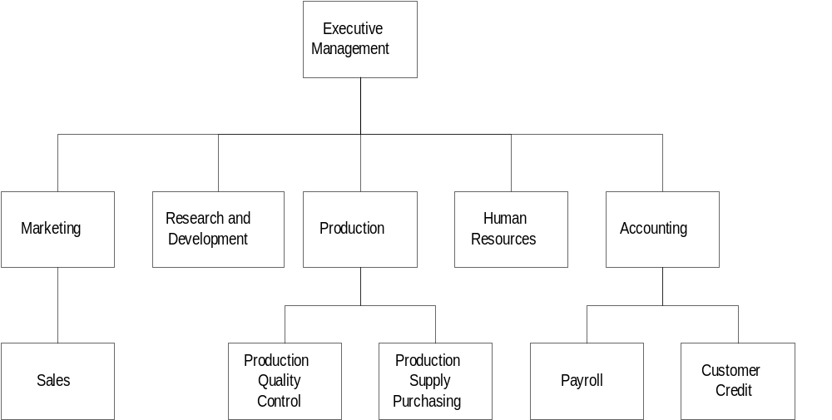

Sample Work Product – Organizational Readiness Unit Relationship

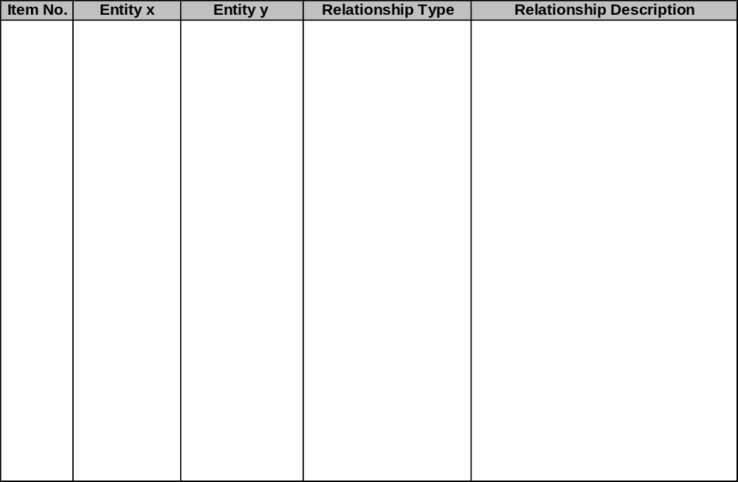

Organizational Readiness Job Profiles

Overview | Based on the analysis completed concerning the current skills inventory by job  and the envisioned job design created, determine the skills gap between the  current jobs and target job design. Job profiles will be created for existing jobs with changes in responsibilities and new jobs created.

Approach | The approach to determining the skill gap is to enumerate the skills necessary for the new organizational structure. This skill set for the target environment should be compared to the current skill set. This comparison will identify the skill gap from the current structure to the target structure. Also by job, identify the skill requirement gaps. This level of skill analysis will be dependent upon the HR practices of tracking skill requirements by job. Finally, after collection of this information create job descriptions for all new positions and document any changes to existing jobs.

Work Product | The typical working documents will be a job description chart that can be prepared and managed in MS Word or MS Excel. Typical column headers that identify the information are job title, tasks, output, tools required, skills required, performance measures, etc.

Input | Sources of information can include the following: skills inventory of current structure, organization chart for target environment, business unit leaders, senior management, personnel department, recruiting manager, work plans, and previous or concurrent activities such as Organizational and process mapping.

See following page for job description chart.

Sample Work Product

Task | Outputs | Tools / Facilities Required | Skill Required | Performance Measures & Targets | Relative Value Grade of Job | FTEs Required

Organizational Readiness Hiring Requirements

Overview | Based on the analysis completed concerning the current skills inventory by job, the envisioned job design created and the job profiles, the hiring requirements can be determined.

Approach | The approach to determining the hiring requirements is to collect the information about the job profiles. Next, identify those resources that can fulfill the job profiles. Identify job profiles that can not be filled with the current skill level. These job profiles will provide the information for the hiring requirements.

Work Product | The typical working documents will be a hiring requirements form that can be created and managed in MS Word or Excel. Typical column headers that identify information are job title, job type, job description, unit/group, years of experience, education, necessary skills, preferred skills, and industry knowledge.

Input | Sources of information can include the following: job profile of existing and new positions, organization chart for target environment, business unit leaders, senior management, personnel department, recruiting manager, work plans, and previous or concurrent activities such as organizational and process mapping.

See following page for hiring requirements form.

Sample Work Product
Item No. | Job Title | Job Type | Unit / Group | Years of Exp. | Education | Nec. Skills | Preferred Skille | Industry Knowledge

Organizational Readiness Training Program

Overview | Once an overall picture of the new organization, the new skills, and job profiles are designed, the necessary training program can be scheduled. By reviewing the typical skills sets required for the new web site and comparing it to the existing skills base, a gap analysis is completed defining what training may need to occur immediately, and what training may occur in later phases of the project.

Approach | The approach to designing the training programs requires understanding the new skills required in the new structure. Then with the current training programs identify what new training programs if necessary should be designed for these new skills.

Work Product | The typical working document will be an MS Excel form that lists jobs along with necessary training. Typical column headers that identify the information are job title, training type/name, internal/external, formal/informal, credits/hours, certification, and description of training and skills developed. Another MS Excel form will provide a schedule of training programs. Typical column headers that identify the information are training type/name, internal/external, formal/informal, start date, finish date, cost, prerequisites, credit/hours, certification, credits/hours, certification, and description of training and skills developed.

Input | Sources of information can include the following: job descriptions, training manuals, course offerings and description, training programs (internal/external), business unit leaders, senior management, and personnel department.

See following pages for jobs and necessary training form and schedule of training programs form.

Sample Work Product – Training Programs
Training Programs:

Item No. | Job Title | Training Type / Name | Internal / External | Formal / Informal | Credits / Hours | Certification | Desc. Of Training Skills Developed

Sample Work Product – Training Schedule
Training Schedule:

Item No. | Training Type / Name | Internal / External | Formal / Informal | Start  Date | Finish  Date | Cost | Prerequisite

Organizational Readiness Changes and New Processes

Overview | A gap analysis can typically be completed at this point by comparing typical web functional units to the existing organizational structure. Also, the team should pay particular attention to the roles and responsibilities developed within the dynamic personalized template wireframes. Within that task, a specific individual is assigned responsibility for maintaining and developing business/content rules for that content region. The purpose of this step is to assess the organization in order to determine the changes needed to enable successful implementation of the new technology and to define a practical listing of opportunities for improvement.

Approach | The approach to identifying the changes and new process needs requires the organization team to document any necessary process changes required to support this effort focused on content management, maintenance, and business rules.

Work Product | The typical working document will be a process inventory list created in MS Excel. This document will list all new processes and processes to be changed. The typical column headers include process name, process function, who performs process, who owns the process, input, output, tools for process, why change/add process, and description of process.

Input | Organization charts and information provided by personnel familiar with the organizational structure. Input from personnel familiar with process flows for the current and new organization especially for content management, maintenance, and business rules.

See following page for process inventory list.

Sample Work Product

Item No. | Process Name | Process Function | Who Performs Process | Who Owns Process | Input | Output | Tools for Process | Why Change/Add Process | Process Description

Organizational Readiness New Processes

Overview | A gap analysis can typically be completed at this point by comparing typical web functional units to the existing organizational structure. Also, the team should pay particular attention to the roles and responsibilities developed within the dynamic personalized template wireframes. Within that task, a specific individual is assigned responsibility for maintaining and developing business/content rules for that content region. The organization team should document any necessary process changes required and any new processes to support this effort.

Approach | The approach to identifying the organization needs requires the organization team to document redesigned existing processes and new processes that are necessary to fit the new organization needs.

Work Product | The typical working document will be process flow diagrams created in MS PowerPoint or Visio prepared to indicate the necessary processes for the organization. An MS Word document can be used for the description of the elements of a process with typical column headers that include source, recipient, resource name, delivery method, etc.

Input | Organization charts and information provided by personnel familiar with the organizational structure. Input from personnel familiar with process flows for the current and new organization.

See following pages for process flow diagram, process flow symbols table, process flow cross-reference, and input/output description chart.

Sample Work Product – Process Symbols
Process Symbols

Consistent process documentation techniques should be used throughout the documentation, assessment, and design/redesign of business processes. One form of process documentation is called a process map. Using standard process mapping symbols, process maps can be used to graphically represent the decomposition of a business process into an interdependent chain of process units at one or more discrete levels of abstraction, and to identify the business process's inputs/suppliers and outputs/recipients.
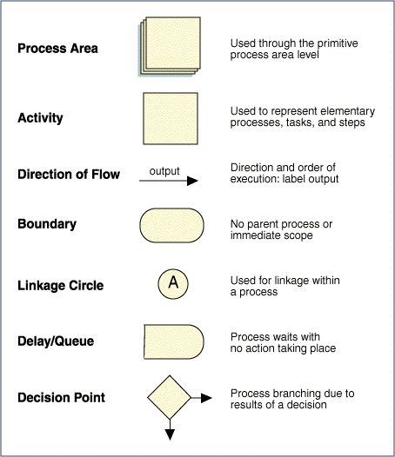
To help team members remember the elements of a process map, the mnemonic SIPCO may be used: Supplier, Input, Process, Customer, Output.

Sample Work Product - Process Flow Diagram

Process maps can be drawn at various levels of abstraction, ranging from maps that indicate what work is done (i.e., decomposition to the elementary process level) to how work is done (decomposition of the elementary processes into constituent tasks and steps):
- Level 1 maps: Each process area symbol represents either a value-chain or support process area.
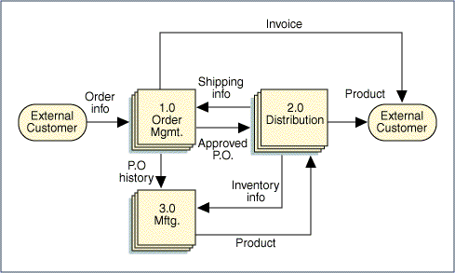
- Level 2 maps: Each Level 2 map represents a decomposition of one of the process areas depicted on a Level 1 map. The Level 2 map below is a decomposition of the Order Management process area on the Level 1 map (i.e., 1.0 Order Mgmt.).
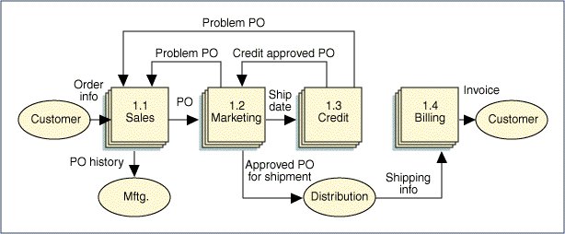
- Level 3 maps: Each Level 3 map represents a decomposition of one of the Level 2 process areas. Each box on the level 3 map represents either a lower-level process area or an elementary process (if the Level 2 process area is a primitive process area).
- Beyond Level 3. Each additional level represents a further decomposition of the process units depicted on the preceding level (e.g., if the Level 3 map depicted elementary processes then the Level 4 map would depict tasks, and the Level 5 map would depict steps).
Note: At each level, boxes are connected by arrows to indicate the direction of output flow and to represent that box's output. The arrows must be labelled with the output (or outcome) of the preceding box.

Sample Work Product - Process Cross-Reference

Process mapping should always begin at the top (Level 1), whether the scope of the project includes the entire enterprise or just one process, function, or business unit.

Since most changes take place at the task level when processes are redesigned, it is generally not necessary or appropriate to develop process maps at lower levels of decomposition.
Tasks may be cross-referenced to the business units having responsiblity for them in the current environment. Such a cross-reference facilitates the linkage of organizational costs to tasks and can reveal issues that need to be resolved to enable performance improvement. One way to represent this cross-reference is to indicate functional boundaries in the Business Process Map at the level depicting constituent tasks.
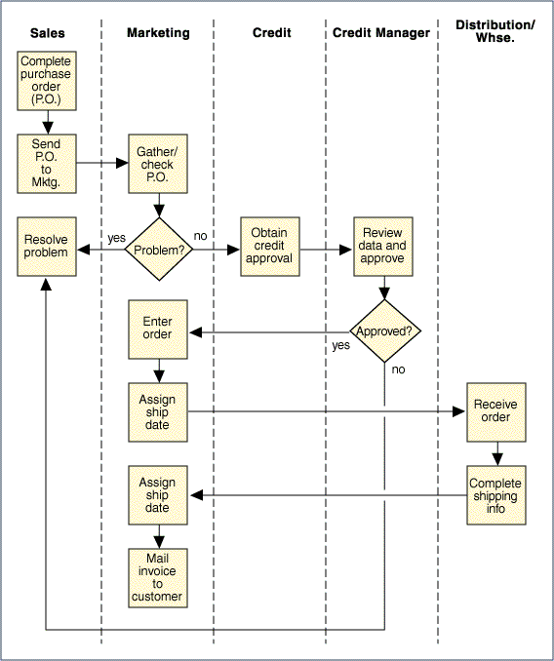

Sample Work Product - Input/Output Description Template
ID | Source | Recipient | Resource name | Resource Desc | Delivery  method | Output medium | Freq. | Vol. | Quality | Cost

Technology Overview

Data Architecture Design

Web Page Program Design

Reporting Design

Interface/Batch/Data Migration Design

Technical Infrastructure Design

Web Page Program Design Overview
Produce pseudo-code for individual javascript pages

Java/C++ custom component design
Javascript Utility/Start-Up Function Design
Identify common javascript page components

Java/C++ Custom Component Design

Overview | BroadVision provides specific functionality through well-defined interfaces, using the One-To-One Component Model. In order to implement additional custom functionality to provide the site visitor a personalized experience, it is recommended that custom components be developed to incorporate this functionality.

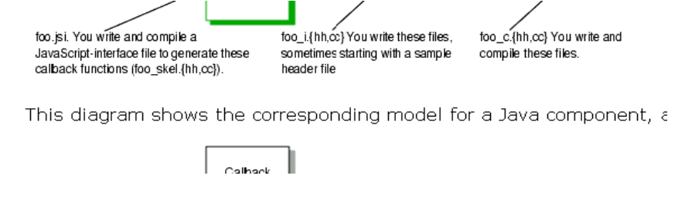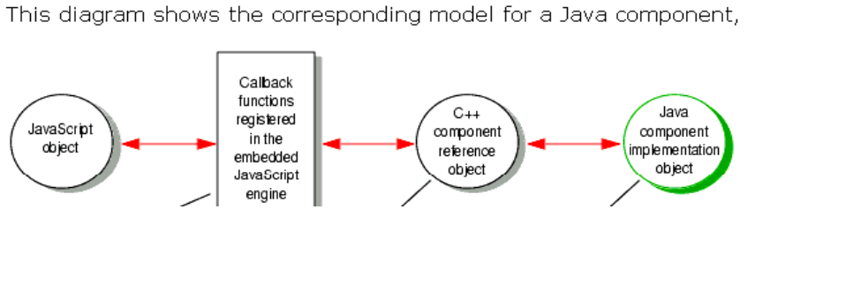Approach | - Custom functionality is identified  - Interfaces for the custom component are designed  - Attributes and methods for the component are designed  Three objects are involved, every time a BroadVision One-To-One JavaScript-visible component is used in a script, as shown below  C++ Custom Component  Developer file to generate functions. Developer created files. Developer implementation.  Java Custom Component  Pre-defined Two pre-defined objects Developer created  The first object or layer is the JavaScript layer and represents the BroadVision Components. The third layer is developer created and does most of the work. The purpose of the second layer, the Component Reference layer is to communicate information between the developer created and BroadVision components.

Work Product | The deliverable is a design document detailing the technical and process aspects of the component.

Sample Design Document | A sample design document is attached below.

Sample Work Product

*** DRAFT***
Small Business Services Portal Engine Project

Design Phase Technical Specifications

Purpose:
<Document Description>

Overview:
<Object Description>

Technologies Used/Required:
Development Platform:
Development Environment:
Transaction Server:
Data Access Technologies:
Other Technologies:

Technical details:
<Brief technical description of object>

<Bullet List of Technical Details>

Process details:
<Brief process Overview>

<Bullet List of Process Details>

List of Functions

1. Class 1 functions
- Function 1
- <Bullet List of Functions>

2. Class 2 functions
- Function 1
- Function 2
- <Bullet List of Functions>

Class Interfaces

- Class 1: <description>

- Function 1 Details:
Function Name: Construct Error; Returns Boolean(0 - Failure, -1 – Success)
Parameter | Type | Pass By | Required | Default | Comments

- Pseudo Code:

//Code for Initial Validation / Initialization

//Process Code

//Code for Error Handling

- Class 2: <description>

- Function 1 Details:
Function Name: Construct Error; Returns Boolean(0 - Failure, -1 – Success)
Parameter | Type | Pass By | Required | Default | Comments

- Pseudo Code:

//Code for Initial Validation / Initialization

//Process Code

//Code for Error Handling

- Function 2 Details:
Function Name: Construct Error; Returns Boolean(0 - Failure, -1 – Success)
Parameter | Type | Pass By | Required | Default | Comments

- Pseudo Code:

//Code for Initial Validation / Initialization

//Process Code

//Code for Error Handling

Sample Work Product - Fleet Schema
User Tables
These tables contain visitor profile information:

BroadVision User Tables
BV_USER_PROFILE
Attribute | Column | Semantics
USER_ID | integer | Visitor ID as defined in BV_USER
NAME | vchar(50) | Name
ADDRESS | vchar(255) | Address
CITY | vchar(50) | City
STATE | vchar(20) | State
ZIP | vchar(20) | Zip Code
COUNTRY | vchar(20) | Country
EMAIL | vchar(50) | E-mail Address
AGE_RANGE | ENUM | Age Range
GENDER | ENUM | Gender
INCOME_RANGE | ENUM | Income Range
NO_HOUSEHOLD | LONG | Number of People in Household
MARITAL_STATUS | ENUM | Marital Status
EMPLOY_STATUS | ENUM | Employment Status
OCCUPATION | ENUM | Occupation
EDUCATION_LEVEL | ENUM | Education Level
BUS_PHONE | vchar(255) | Business Phone
HOME_PHONE | vchar(255) | Home Phone
WANT_MESSAGE | LONG | Want Messages
INVALID_EMAIL | LONG | Invalid E-mail Address
LAST_LOGIN_DATE | DATETIME | Date of Last Login
AVG_LOGIN_DAYS | DOUBLE | Average Days Between Logins
NUMBER_LOGIN | LONG | Number of Login Times
LAST_MOD_TIME | DATETIME | Date/Time of Last Modification to Profile

SBS User Tables
SBS_USER_PROFILE(1:1)
Attribute | Column | Semantics
USER_ID | integer | Visitor ID as defined in BV_USER
SALUTATION | ENUM | Salutation
FIRST_NAME | vchar(50) | First Name
LAST_NAME | vchar(50) | Last Name
SECRET_QUESTION | vchar(100) | Secret Question
BUS_FAX | vchar(255) | Business Fax
BUS_ROLE | ENUM | Business Role
CONTACT_METHOD | ENUM | Contact Method

SBS_USER_COMPANY(1:1)
Attribute | Column | Semantics
USER_ID | integer | Visitor ID as defined in BV_USER
COMPANY_LIFE_CYCLE | ENUM | Life Cycle
COMPANY_CUSTOMER | ENUM | Already a customer?
COMPANY_NAME | vchar(50) | Company Name
COMPANY_ADDRESS | vchar(255) | Company Address
COMPANY_CITY | vchar(50) | Company City
COMPANY_STATE | vchar(20) | Company State
COMPANY_ZIP | vchar(20) | Zip code
COMPANY_PHONE | vchar(255) | Company Phone
COMPANY_FAX | vchar(255) | Company Fax
COMPANY_INDUSTRY | ENUM | Industry
COMPANY_NUM_EMPLOYEES | ENUM | Number of Employees

SBS_USER_COMPANY_CONCERN(1:n)
Attribute | Column | Semantics
USER_ID | integer | Visitor ID as defined in BV_USER
CONCERN | ENUM | Concern

SBS_USER_INTEREST(1:n)
Attribute | Column | Semantics
USER_ID | integer | Visitor ID as defined in BV_USER
INTEREST | ENUM | User Interest

SBS_USER_AFFILIATION(1:n)
Attribute | Column | Semantics
USER_ID | integer | Visitor ID as defined in BV_USER
AFFILIATION | ENUM | User Affiliation

Content Tables
BroadVision Content Tables
BV_EDITORIAL
Attribute | Column | Semantics
OID | integer | A unique number that identifies content (Object ID).
ED_NAME | vchar(80) | Editorial name.
STORE_ID |  | Service ID as defined in BV_STORE.
CREATION_TIME |  | Creation Time
STATUS |  | Status: offline (0) or online (1).
DELETED |  | Deleted status: not deleted (0) or deleted (1).
LAST_MOD_TIME |  | Time stamp for the last time the editorial was modified.
AUTHOR | vchar(128)
START_DATE | date-time | Effective start date.
END_DATE | date-time | Effective ending date.
PUB_DATE | date-time | Published date.
PUBLISHER | vchar(128) | Name of publisher.
LANGUAGE | vchar(32) | Language of editorial.
CONTENT_FORM | integer | Location of editorial text: 0 in the CONTENT_TXT column; 1 in a file named by CONTENT_FILE.; 2 in a URL named by CONTENT_URL
CONTENT_TXT | text | Editorial text column. Avoid using this because performance is slower, it is harder to edit, and it is harder to load from file. Use CONTENT_FILE whenever possible.
CONTENT_FILE | vchar (128) | Pathname of content file.
MIME_TYPE | vchar (128) | MIME type of the content specified in the CONTENT_FILE column.
PREVIEW_IMAGE | vchar (128) | Preview image file of editorial.
PREVIEW_IMAGE_WIDTH | integer | Width of preview image.
PREVIEW_IMAGE_HEIGHT | integer | Height of preview image.
FULL_IMAGE | vchar(128) | Full image file of editorial.
FULL_IMAGE_WIDTH | integer | Width of full image.
FULL_IMAGE_HEIGHT | integer | Height of full Image.
AUDIO_FILE | varchar(128) | Audio file of editorial.
VIDEO_FILE | varchar(128) | Video file of editorial.
SOURCE | varchar(50) | Source of editorial.
COMMENTS | varchar(255) | General comments.
BILLABLE | integer | Is content billable; Not Billable (0), Billable (1).
PRICE | numeric(18,2) | Microtransaction price.
RATING | float | Average Visitor Feedback Score
NO_VOTES | int | Total Number of Visitor Feedback Votes
TOTAL_RATING | float | Total Visitor Feedback Score

SBS Content Tables
SBS_EDITORIAL
Attribute | Column | Semantics
KEYWORDS | vchar(255) | Comma separated list of keywords.
CONTENT_URL | vchar(255) | URL of content
PRODUCT_NAME | vchar(255)
COST | vchar(255)
RELATED_INFO | vchar(2000)
CONTACT_NAME | vchar(80)
CONTACT_EMAIL | vchar(255)
CONTACT_PHONE | vchar(255)
Matching Attributes
STATE | vchar(20)
ZIP | vchar(20)
REGION | vchar(255)
PLATINUM_CUSTOMER | ENUM | Boolean
HOME_OFFICE | ENUM | Boolean
CUSTOMER | ENUM | Boolean

SBS_EDITORIAL_LINK
Attribute | Column | Semantics
OID | integer | A unique number that identifies content (Object ID).
LINK | vchar(255)

SBS_EDITORIAL_INDUSTRY
Attribute | Column | Semantics
OID | integer | A unique number that identifies content (Object ID).
INDUSTRY | ENUM

SBS_EDITORIAL_CONCERN
Attribute | Column | Semantics
OID | integer | A unique number that identifies content (Object ID).
CONCERN | ENUM

SBS_EDITORIAL_INDUSTRY
Attribute | Column | Semantics
OID | integer | A unique number that identifies content (Object ID).
INDUSTRY | ENUM

SBS_EDITORIAL_NUM_EMPLOYEES
Attribute | Column | Semantics
OID | integer | A unique number that identifies content (Object ID).
NUM_EMPLOYEES | ENUM

SBS_EDITORIAL_LIFE_STAGE
Attribute | Column | Semantics
OID | integer | A unique number that identifies content (Object ID).
LIFE_STAGE | ENUM

SBS_EDITORIAL_ROLE
Attribute | Column | Semantics
OID | integer | A unique number that identifies content (Object ID).
ROLE | vchar(255)
SBS_EDITORIAL_PRODUCT
Attribute | Column | Semantics
OID | integer | A unique number that identifies content (Object ID).
PRODUCT | OID

Enumerated Types

GENDER
Male
Female

INCOME_RANGE
<$14,999
$15,000-$19,999
$20,000-$39,999
$40,000-$59,999
$60,000-$75,000
>$75,000

MARITAL_STATUS
Married
Unmarried

EDUCATION_LEVEL
In Graduate School
In High School
High School
In College
College
Graduate

OCCUPATION
Professional
Managerial
Services
Sales
Clerical
Technical
Other

EMPLOY_STATUS
Full Time
Part Time
Student
Homemaker
Retired
Unemployed

AGE_RANGE
Under 15
15-17
18-24
25-34
35-44
45-54
55-64
Over 65

SALUTATION
Mr.
Ms.
Mrs.
Dr.

BUS_ROLE
Owner
Financial Officer
Book Keeper
Office Manager
Sales / Marketing
Customer Service
Independent Contractor

CONTACT_METHOD
E-Mail
Phone
Postal Mail

COMPANY_LIFE_CYCLE
Start-Up
High Growth
Mature
Preparing to Sell

CONCERN
Business Planning
Finance
Human Resources
Legal
General Management Issues
Sales & Marketing
Technology

COMPANY_INDUSTRY
Agriculture / Forestry / Fishery
Advertising / PR / Marketing
Architectural / Engineering
Business Services
Construction / Building Professionals
Entertainment
Finance / Accounting / Investment
Health / Medical
Insurance / Real Estate
Legal
Lodging
Manufacturing
Mining
Professional Services
Restaurant
Retail Trade
Transportation
Wholesale Trade
Other

COMPANY_NUM_EMPLOYEES
Pre-start-up
1-2
2-10
22-25
26+

INTERST
CPAs
Women Business Owners
Legal Professionals
Start-ups

AFFILIATION
???

Issues:
- Is company information specific to user? (If multiple users are from the same company, do we repeat the info in each profile? How to we synch this up? Who has authority to change the info? Which info is definitive?...)
- Need valid values for affiliations
- On editorial – File & Text/Body – is this an either/or relationship
- Home office. Boolean?

Sample Work Product - Common Component Functions
File Name | Function Name | Input Parameters | Output Parameters | Functionality
common_utils.js | isRegisteredUser | N/A | true/false | Determine whether the current user is registered or not
common_utils.js | displayDate | N/A | string (date) | Return the current date as a preformatted string
common_utils.js | displayDate | N/A | sting (time) | Return the current time
validate.js | validateEmail | String | true/false | Determine if a string contains "@" followed by a "."
validate.js | validateUserName | String | true/false | Determine if a username is already taken
validate.js | validatePasswords | String, String | true/false | Confirm that the two passwords are the same, and have 6 characters
valdate.js | validateZipCode | Number | true/false | Confirm that a provided zip code has 5 or 9 digits
validate.js | validatePhone | Number | true/false | Confirm that a provided phone number has 10 digits
validate.js | validateCharacters | String | true/false | Confirms that the input string (i.e. name) has valid characters
error.js | getErrorMessage | String (error code) | string (error message)/false | Return an error message based on a specified error code
error.js | redirectToErrorPage | String (error code) | rediects to an error page/false | Redirects the browser to an error page, displays an error message and a link back to the previous page

Design JavaScript Utility / Startup Functions

Overview | During this activity, common tasks whose functionality is unlikely to change over time are identified and encapsulated into startup functions. These Startup functions get loaded once, and once loaded their functionality is available to all pages.

Approach | Determine common tasks that are used in multiple pages. Identify them by unique names and organize them into startup function pages (.js), adhering to the programming standards, a sample of which is attached.

Work Product | The typical work product is a document listing the identified common functions organized by startup function pages (.js). A more complex function will have a corresponding technical design documenting its purpose, as well as technical and process aspects.

Sample Work Product | A sample work product is attached below.

Sample Work Product
*** DRAFT***
Small Business Services Portal Engine Project

Design Phase Technical Specifications

Startup function - Utilities.js

Function: fnInitPage()

Description:
Every page script (with certain very specific exceptions,
such as the login page) MUST call this function at the
beginning of execution to make sure that we still have….

Parameters:
location - a string, the value to be printed out in the log
indicating where the function is being called from

Return Value:
None

Function: fnClearCustomerInfo()

Description:
Clear the current customer info from local storage.

Parameters:
None.

Return Value:
None

Purpose:
<Document Description>

Overview:
<Object Description>

Technical details:
<Brief technical description of function>

<Bullet List of Technical Details>

Process details:
<Brief process Overview of function>

<Bullet List of Process Details>

- Function Details:
Function Name: Construct Error; Returns Boolean(0 - Failure, -1 – Success)
Parameter | Type | Pass By | Required | Default | Comments

- Pseudo Code:

//Code for Initial Validation / Initialization

//Process Code

//Code for Error Handling

A typical Startup Utility/Function script

function setSessionMappingInfo(storeType)
{

<function body>

}

function filter_content_types()
{

<function body>

}

function build_inclusion_list()
{

<function body>

}

JavaScript Startup Function Programming Standards

- Identify functionality that is not likely to change over time, to encapsulate in the startup function.

- When naming script functions in startup scripts, take care that the function names do not duplicate the names of functions in other startup scripts or the names of functions in page scripts.

- Place startup scripts in a separate directory containing only startup scripts.

- Place user-defined startup scripts in a separate directory. These directories are specified while configuring the Interaction Manager.

- Do not directly reference JavaScript-visible component objects in startup scripts; encapsulate them in functions.

Sample Working Document - Development Environment Guide



Fleet SBS Portal Implementation
Development Environment Guide

Purpose and Scope
The purpose of this document is to describe the specifics of the development environment. The document will encompass a list of components, a description of the BroadVision file and directory structure, and the general development environment configuration. The document will be used as a guide for those accessing the Development environment.

System Architecture
The development environment resides on across multiple machines in heterogeneous configuration (NT and UNIX).

Hardware
Servers

The following describes the configuration for the development servers:

Machines | OS | Name | IP | Function | CPUs | Memory | Disk
1 Compaq | NT | uswalwebd01 | 10.175.95.66 | - Web Server
1 SUN e80 | Solaris 5.6 | ecim1dev | 10.175.95.59 | - Interaction Manager Server
1 SUN e80 | Solaris 5.6 | eccd1dev | 10.175.95.62 | - Root Host One-To-One Server
1 SUN e80 | Solaris 5.6 | ecdb1dev | 10.175.95.58 | - Database Server

Currently the development environment machines reside on the ma.fbf1.com domain (i.e. ecim1dev.ma.fbf1.com) with a 10.175.95.* subnet IP address.

Development Workstations
The developers will work on various different NT Workstations each with the following minimum configuration:

Machines | OS | Function | CPUs | Memory | Disk
Various | NT Workstation 4.0 | - Developer Workstation | Pentium | 256MB | 1GB

Software
The following applications and supporting software will need to be installed and configured in the development environment:

Web Server
- IIS
Database

The database management system will be Oracle 8.1.6 with the following components:
- SQL*Plus
- PL/SQL
- SQL*Net
- TCL/IP Protocol Adapter
- Oracle ODBC Driver
- Pro*C/C++

BroadVision

BroadVision One-To-One Enterprise version 5.0 will be installed in the development environment. The application will be configured for both the One-To-One Servers (Root Host) and the Interaction Managers. Each Interaction Manager will be configured with one engine and two threads per engine. The following development tools will be installed on the development boxes:

- ?Iona Orbix version 2.3MT
- ?Rogue Wave
- Tools.h++ version 7.0.2
- ?Verity Search ’97 version 2.4.0
- ?Java Virtual Machine
- ?XML4C XML parser
- ?Purify version 5.0.1
- ?HP ANSI C++ Compiler version 3.13
- ?Orbix IDL Compiler version 2.3MT
- ?HTTP Component

Developer Workstations

- NT Workstation 4.0 Service Pack 4
- MS Office 2000
- IE 5.0 SR1
- Outlook 2000
- Homesite 4.5
- Exceed 5.3
- Broadvision Command Center 4.1
- McAfee Virus Protection
- Microsoft Project 98
- WinZip 7.0

Configuration
The following section will describe the configuration of the Development environment with regard to BroadVision and the web server.

Web Server

There will be one HTTP server in the development environment, which will use a named CGI gateway to connect to the Interaction Managers. The port used for the web server will be port 8011.

BroadVision

There will be three BroadVision instances running within the development environment: EC_developement, EC_dba, and EC_fbuild. Developers will work within the EC_development environment, while the EC_dba environment will be reserved for developing and testing database scripts, table extensions, etc. The EC_fbuild environment will exist as a staging environment where developers will be able to promote their code when it is ready to be moved to the next environment; this instance will also

The individual Interaction Managers for the EC_development, EC_dba, and EC_fbuild applications will be configured to have one engine with only two threads. The following is a list of the Development environment Interaction Managers.

Application Name | Interaction Manager
EC_development | ?
 | Unix_id_1
 | .
 | .
 | .
 | Unix_id_n
EC_dba | ?Fleetdba
EC_fbuild | ?Fleet

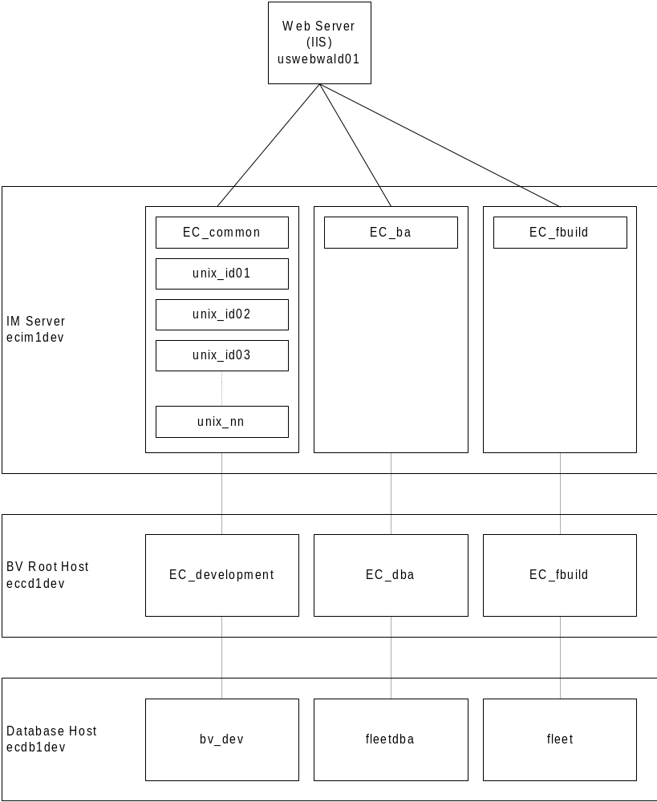

Diagram 1: Basic Development Environment Architecture

File System Layout
The file system for development environment will be configured to host 3 BroadVision applications all on one IIS web server.

CGI Applications
CGI will be used for the communication between the IMs and the Web Server in the Fleetdev instance (all other instances will use ISAPI). The CGI directory for the Web Server will reside under:

/?/?/cgi-bin

Each IM will have a corresponding named gateway applications which will be copied to the CGI directory on the IIS server.

Script Root
The interaction managers locate scripts using a path that is relative to the script root. All of the applications share the same script root, but the application scripts are partitioned into directories beneath the root. The following list provides the name and location of the script roots for the development environment.

Application Name | Interaction Manager | Script Root Location
EC_development | ?fleetdev | ?/apps/broadvision/script-root/fleetdev
 | Unix_id_1 | $home/script-root/
 | . | $home/script-root/
 | . | $home/script-root/
 | Unix_id_n | $home/script-root/
EC_dba | ?fleetdba | ?/apps/broadvision/script-root/fleetdba
EC_fbuild | ?fleet | ?/apps/broadvision/script-root/fleet

Document Root
The document root is the preferred location for all static HTML (including those pages with only client-side scripting) and images. Each application uses a subdirectory of the document root to store its static files and images. Storing the static files in the document root, as opposed to the script root, means that they are processed only by the web server without placing extra load on the interaction managers.

The document root for the Development environment can be found at:

\\uswalwebd01\d_drive\bv1to1\cdev

All Development Interaction Mangers will reference the same doc root, so that images and static HTML does not need to be duplicated.

Port Usage
The following section details the port assignment for the Development environment.

Note: The IT_DAEMON port assignments are the ports that the Command Center must be pointed to in order to access the content specific to the desired application.

Application Name | Used By | Port Number | Purpose
 | IIS | 8011 | HTTP traffic for the live sites.
 |  | 443 | Secure HTTP traffic for the live sites.
EC_development |  | 22257 | IT_DAEMON_PORT Controls CORBA traffic for application.
EC_dba |  | ? | IT_DAEMON_PORT Controls CORBA traffic for application.
EC_fbuild |  | ? | IT_DAEMON_PORT Controls CORBA traffic for application.

BroadVision Administration
The following section describes the various aspects of administering the BroadVision application.

Stopping and Starting Interaction ManagersBV1TO1_VAR
Developers will have access to imgr_conf to start and stop their own Interaction Manager. This access will be provided via a script that will effectively run as bvuser (the owner of the BV instance) accepting a parameter (the named IM – which is also the user’s unix id) to determine which IM to stop or start.

imgr_conf –a start –A Unix_id
imgr_conf –a stop –A Unix_id

You can check to see if your interaction manager is running by typing in the following command:
ps -ef |grep bvsmgr |grep unix_id |grep -v 'grep'

Starting/Stopping the Application
Individuals will not be able to stop and start the One-To-One servers. This will need to be done by either the system admin rep or team leads. You may however want to check to see whether or not the Orbix daemon is running (this is the CORBA server that allows the IM to talk to the Root Host. In order to do this use the following command

ps –ef |grep orbixd |grep bvuser |grep –v ‘grep’

Note bvuser is the UNIX user that owns the development environment

Troubleshooting
Should both you IM and Orbix Daemon be up an d running and you are still experiencing problems you will unfortunately need to contact the system admin or team lead, who should be able to check and see if the database is up.

Log Files
The log files for BroadVision will provide insight to the daily functions of the application. They are a good source of information to help troubleshoot issues regarding the BroadVision applications.

The logs can be found in:

$BV1TO1_VAR(EC_development)/logs/ecim1dev
$BV1TO1_VAR(EC_dba)/logs/ecim1dev
$BV1TO1_VAR(EC_fbuild)/logs/ecim1dev

Developer's will have read access to these logs and can view them interactively via the following command (keep in mind that the logs are stored with a date stamp):

> cd /opt/bv1to1/EC_development/logs/ecim1dev
> tail –f bvlog.out.20000921

Clearing Cache

When performing changes on scripts that are included (i.e. #include, callscript()) into other files, it might be necessary to clear the cache before these changes would be reflected in a browser. To do this, exit your browser and type the following commands at Unix prompt:

$cache_utl –a Unix_id –e script_cache -d flush
$cache_utl –a Unix_id –e request_cache

Then restart your browser and navigate back to the updated script. All the changes should now be reflected. If this is not the case, than close your browser again and perform the touch command on the file that has been updated, as well as the file that includes it. For example:

$touch main_file.jsp ./utilities/utility_file.jsp

Sample Work Document - Scripting Guidelines

Scripting Guidelines
BroadVision
3 New England Executive Park
Burlington, MA, 01803
Phone: (781) 505-6700
Fax: (781) 505-9889

BroadVision JavaScript Architecture and

Best Practices

Issue Date: 2000-09-22
Intro
This document attempts to provide a consistent approach to the development of JavaScript in a BroadVision implementation. The document is split into three sections. The first provides style guidelines which includes naming and formatting conventions. The second provides JavaScript best practices which is a collection of tips and techniques for improving performance, and making the code more robust. Finally, a section on JavaScript architecture defines a specific pattern for using scripts to generate HTML.
Style Guidelines
In order to increase the readability and hence maintainability of the code, it is essential to follow consistent style guidelines. This will ensure new development team members will be able to quickly and easily work with any piece of code. Additionally, consistent naming conventions will give visual cues to the intent of a piece of code.
Naming Conventions
Use meaningful names, and avoid non-standard abbreviations.
Type | Convention | Example
Class | Mixed case, start with upper | MyClass
Object | Mixed case, start with lower | myClass
Method | Mixed case, start with lower | myClass.aMethod
Property | Mixed case, start with lower | myClass.aProperty
Function | Mixed case, start with lower | aFunction
Local Variable | Mixed case, start with lower | localVariable
Constant | upper case | THE_CONSTANT
Function Parameter | Mixed case, start with lower | functionParam
File | Mixed case, start with upper | MyFile.jsp
HTTP Form Input | lower case | username
Database Table | upper case, prefix with FLEET_ or SBS_ | FLEET_UPROF  SBS_EDITORIAL
Database Table Attribute | upper case | INCOME_LEVEL

Directory Structure
scriptroot
fleet
sbs
layout
StandardLayout.jsp
PopupLayout.jsp
<other layout scripts>
common
toolbar.jsp
header.jsp
<other common scripts>
login
register
<other processes requiring with more than a few scripts>

script_library
fleet
sbs
Comments

File Header
//
// File: FileName.jsp
// Explain the overall purpose of this file.
// Functions:
// functionOne (param1, param 2)
// Brief explanation of function
// funcitonTwo (param1)
// Brief explanation of function
//

Class Header
//
// Class: MyClass
// Explain the overall purpose of the class.
// Methods:
// methodOne (param1, param 2)
// Brief explanation of method
// methodTwo (param1)
// Brief explanation of method
//

Function Header
//
// Function: MyClass
// Explain the overall purpose of the class.
// Pre Conditions [if any]
// Pre condition one [explain non-standard global variables, or
// properties that need to be set for this function to correctly
// work. No need to include standard objects like Session, ...]
// Args:
// arg1
// Brief explanation of arg
// arg2
// Brief explanation of arg
// Returns:
// Explain return value
// Post Conditions: [if any]
// Post condition one
// [explain global variables, or properties that need are
// set after this function is executed.]
//

Version Comments
Version comments should be entered into the source code control software whenever a file is commited. If update is in response to a defect or change request, enter the defect ID as well.
Inline Comments
Throughout the code place inline comments explaining the functional flow.
Structure

Spacing
Use 4 spaces to indent. The settings on your editor should replace tabs with spaces.

Placement of Brackets
Brackets should line up and have the same indentation level as the current code block.
if ()
{
for ()
b {
}
}
else
{
while ()
{
}
}

JavaScript Best Practices

Performance Considerations
The following JavaScript coding tips are general coding tips.
Avoid crossing the JS/C++ boundary wherever possible:
var list = category.childContent();
for (i = 0 ; i < list.length; i++)
{
Response.write('<TD>');
Response.write(list.get(i).SKU);
Response.write('</TD><TD>');
Response.write(list.get(i).PRICE);
Response.write('</TD>');
}

This could be better done:
var list = category.childContent();
var length = list.length;
for (i = 0; i < length; i++) {
item = list.get(i);
Response.write('<TD>' + item.SKU + '</TD><TD>' + item.PRICE + '</TD>');
}

Don't use localRedirects(visitScript)
if (btn == 'OK')
{
visitScript('ok.jsp');
}
else
{
visitScript('cancel.jsp');
}

localRedirect is a very slow operation and should only be used in error pathways. If you must jump to another script, use server-side includes:
function ok_script()
{
%> <!--#include file = "ok.jsp" --!> <%
}

function cancel_script()
{
%> <!--#include file = "cancel.jsp" --!> <%
}

if (btn == 'OK')
{
ok_script();
RETURN();
}
else
{
cancel_script();
RETURN();
}

Avoid contentByQuery and contentByCondition.
It always makes a query directly to the database, which can be a major drain on system performance. Many times, you can structure your application flow to use methods that get data from the cache, which is several orders of magnitude faster.
Take advantage of the Process and Session objects.
If there is data that you have to compute or retrieve from the database, get it once and stuff it in the Process object. Use accessor functions for this type of data:
function getStateList()
{
var stateList = Process._STATE_LIST;
if (stateList == null)
{
stateList = cntMgr.contentByQuery("SELECT * FROM STATES",0);
Process._STATE_LIST = stateList;
}
return stateList;
}

If you want to put a navigation bar on every page, compute the HTML for it once for the session, put the string in the Session object and then for each page, retrieve it and blast it out to the browser directly.
Take advantage of native JavaScript objects when returning data from functions.
JavaScript does not have "out" parameters, but you can construct native objects and stuff as many properties as you like:
function getTotals()
{
var ret = new Object();
ret.subtotal = computeSubtotal();
ret.taxes = computeTaxes();
ret.total = ret.subtotal + ret.taxes;
}

Use native JS objects(or BVI_Properties if you need persistance) as hash tables.
var noises = new Object();
noises['dog'] = 'bark';
noises['cat'] = 'meow';
noises['pig'] = 'oink';

for (x in noises)
{
print('noises.' + x + ' = ' + noises[x]);
}

Property lookups like this in JavaScript are pretty quick. Don't do linear scans through arrays if you can avoid it.
Be careful with function naming.
Functions are cached by the system, and the names are global across all scripts. If you have two functions with the same name in two different scripts, you can see some very strange behavior. Add the following line to your startup scripts:
warnIfFunctionRedefine(true);

This will generate messages in the error log to let you if this happening.
Avoid <%= syntax, or use the optimizer.
Each usage of the <%=(or shortcut), will cause a call to Reponse.write which is an extra cross. This comes up a lot when making tables:
<TD><%= name %></TD><TD><%= sku %></TD><TD><%= price %></TD>

This will be translated to:
Response.write('<TD>');
Response.write(name);
Response.write('</TD><TD>');
Response.write(sku);
…

It's much better to concatenate stuff together and send it out with one Response.write:
Response.write('<TD' + name ...);

Use the script optimizer and fastconcat.
"fastconcat" is a JS primitive function that does string concats about 2-3x faster than using groups of '+'. The script optimizer cleans up whitespace and removes comments. It also removes the <%= and makes them into fewer crosses. Tests have shown about a 25% speedup on average(your mileage may vary).
Use the cursor in the BVI_ContentList:
var list = getList();
var length = list.length;
for ( i = 0; i < length; i++)
{
var row = list.get(i);
print(row.SKU);
}

The cursor lets you avoid creating an extra variable:
var list = getList();
var length = list.length;
for ( i = 0; i < length; i++)
{
list.cursor = i;
print(list.SKU);
}

JavaScript Architecture
Critical to the success of any BroadVision implementation is a JavaScript Architecture. The intent is to solve recurring architectural issues, provide common components, and provide a consistent approach to JavaScript development. Thereby reducing the burden on individual developers, providing a framework for reuse, and increasing the maintainability of the code.
This architecture lays such a foundation. It provides a general structure for integrating JavaScript into static HTML templates. It also provides common components, including an API for dealing with CGI environment variables.
Script Types
The framework is composed of several layers:

Layout Script
Draw Script
Manager Script
BV Script

Layout Script
Most pages on a site follow a common pattern. For instance, pages often have a main area, with a toolbar to the left, and a console along the top of the page. The layout script encapsulates the generation of this HTML.

The layout script is responsible for generating the HTML that defines the overall layout of a page, without generating HTML for a specific area of the page. Embedded within the layout script should be appropriate callScript’s to generate each specific area.

Following the above example, the layout script would define the HTML to place the toolbar, console, and main areas in relation to each other or the page as a whole; however, the script would not generate the HTML for the specific areas of the page.

When naming layout scripts, the name should end in ‘Layout.’ For example : StandardLayout, PopupLayout.

Draw Script
The draw scripts are responsible for generating the HTML for a specific area of the page. Additionally, a draw script should handle any actions (form posts or url links that require processing)*

If a draw script is complex or easily factorable, an effort should be made to us callScripts to factor this page into separate areas.

In order to maximize the separation of JSP and HTML an effort should be made to do all of the JSP processing at the top of the script. Additionally, use of manager scripts should be used to do any non-trivial processing.

Examples of draw scripts are : Toolbar.jsp, Console.jsp, Login.jsp, HomePage.jsp.

Manager Scripts
In order to increase the separation of JSP and HTML use manager scripts to do any non-trivial script processing. One of the advantages here is this script is a candidate for conversion to a component.
The manager script should define a class with appropriate methods. To make this class available a global variable should be defined with the same name as the class, except using a lower-case first letter.

When naming manager scripts, the name should end in ‘Manager.’ For example : StandardLayout, PopupLayout.

A Concrete Example:
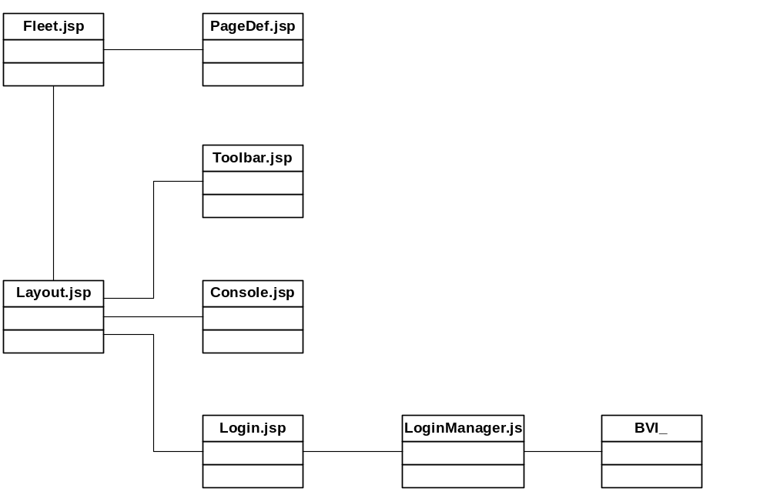
Fleet.jsp
Responsible for reading in the CGI environment variable ‘pgClass’ and determining which scripts are needed to realize the page.
PageDef.jsp
Maps individual pgClass’s to a layout script and any additional scripts necessary to fill in framework layed out by the layout.
Layout.jsp
This script generates the HTML to draw the framework of a page. Multiple layout scripts are generally necessary for one site. Examples could be : Layout (Used to draw a page with a toolbar and console) PopupLayout (Used to draw a simplified page for use with popup windows).
Toolbar.jsp
This script generates the HTML to draw the toolbar. It is called from a layout script
Console.jsp
This script generates the HTML to draw the top console. It is called from a layout script
Login.jsp
This script generates the HTML to draw the main portion of the login page. It is called from a layout script. The first half of the script is used to process any actions (form submits) that may occur on the page. The action handler will typically make calls to a manager object to do the bulk of the processing. The second half of the script should make calls to a manager object to retrieve content and display this in the HTML. The JSP calls should be separated from the HTML as much as possible.
LoginManager.jsp
Wraps the BV API’s. The bulk of the JSP processing should occur here.

Handling Actions
Draw scripts should handle any action within that page. The cgi environment variable ‘action’ should be set to indicate the page should process an action.
<%
if (Request.value (‘action’) == ‘login’)
{
...
}
%>
...
<input type=”submit” name=”action” value=”login”>
...

Caching
Instead of recomputing expensive operations each time a page is viewed. An alternative is to cache the results of the operation the first time, and then reuse the results for a period of time.
When deciding whether to cache specific information, the developer should consider the how expensive the operation is, how often the data will be accessed, how much memory it will take to cache the data, and if BroadVision already caches the data.
Caching should occur within a manager script if possible. The data should be stored either on the Session or on the Process, depending if the data is specific to the current user. The name of the property on the Session or Process should always start with the name of the specific manager class or draw script and an underscore. Session.HomePage_data.
Additionally, when using cache, it is important to set a timeout for the cache. Use the FLEET_CONFIG table to set a timeout for the specific cache. The name should start with CACHE_TIMEOUT_ and end with the name of the cache (in upper case). Following the above example : CACHE_TIMEOUT_HOMEPAGE_DATA.
Common Scripts / Components

Page
The page constructor is a global function and can access Request, Response, Session, and Process. It will assign these objects to itself and perform the functionality of InitSessionState(). The page object will also contain several properties and methods.
Page properties
Page.Request: holds the BVI_Request object for this page request.
Page.Response: holds the BVI_Response object for this page request.
Page.Session: holds the BVI_Session object for this page request.
Page.Process: holds the Process object for this Interaction Manager.
Page.pageBase: holds the base name of the page (“/cgi-bin/bvsm”).
Page.pageName: holds the full local URL to the script (“cgi-bin/bvsm/mydir/home.jsp”).
Page.pagePath: holds the full local URL path to the script (“cgi-bin/bvsm/mydir/”).
Page.serverURL: holds the full URL to the page.
Page.log: holds a BVI_Log object.
Page.visitorManager: holds a BVI_VisitorManager object.
Page.serviceCM: holds a BVI_ContentManager for this service.
Page.curSecs: holds the number of seconds elapsed since 1970 before this Page object’s creation.
Page.defArgs: holds the global page arguments.
Page.isCookieSet:: specifies whether a BV_IDS cookie was set.

Identify Common Components

Overview | This activity entails identification and design of components common across multiple web pages.

Approach | Determine common components that are used in multiple pages.

Work Product | The typical work product is a sample wireframe depicting the identified common components and their location on the webpage.

Inputs | Refer to work products from the "Develop wireframes" and "Develop Preliminary Information Architecture/Site Map" activities in the Definition Phase.

Sample Work Product | A sample wireframe is attached below.

Sample Work Product

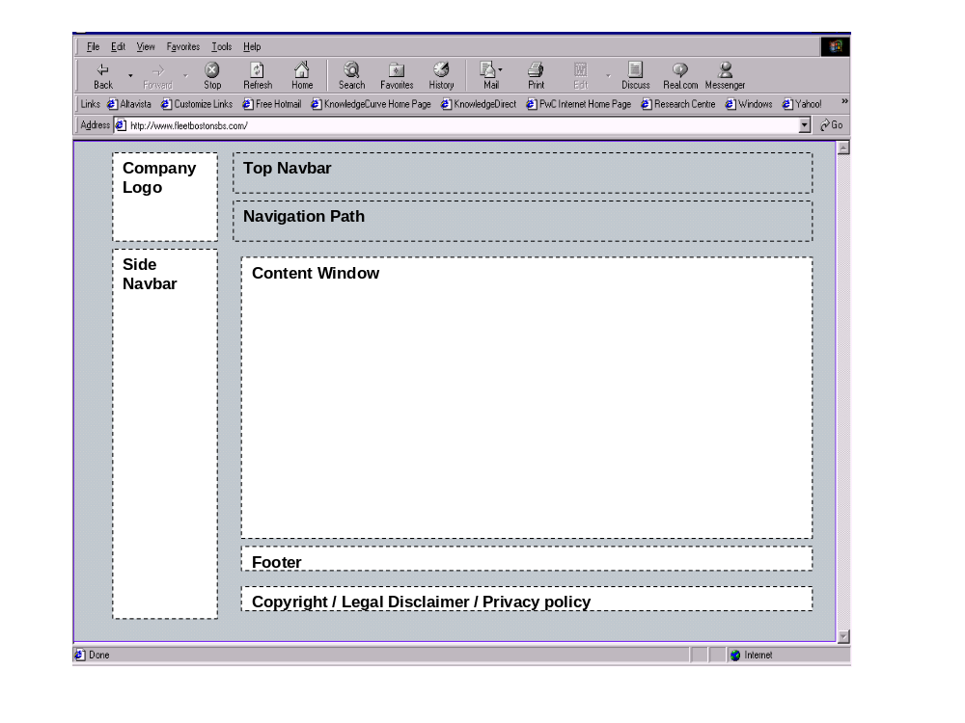
Sample Work Product - common_utilities_library_design

Fleet Contact | Design Signoff | Date
PwC Functional Contact | Design Signoff | Date
Process -
PwC Technical Contacts | Design Signoff | Date
BroadVision -

common_utils.js - Design Details:

Purpose
The Common Utilities library contains functions that are used for handling of common logic processing, encountered by individual scripts.

Page Layout
N/A

Page Definition
Provides details for each and every item on the web page.

Title: | Common_Utilities_Library
Resolution: | N/A

Template
Static/Dynamic | Dynamic
HTML/JSP: | common_utils.js
Frame/No frame: | No frame (for internal page only)

Ref # | Object Type | Object Name | Source  (System) | Default | Required? I added this field | Comments/  Considerations

Legend
Ref # : object number from screen shot
Object Type: refers to the type of the object on the page (i.e. text, label, link, image, etc.)
Default: any default value to populate the object
Source (System): source system providing the content of the object
Source (DBMS): source database if the source of the object resides in a related DBMS in Legacy system or the Enigma
Comments: any general comments

Session Information

Session data CREATED:

Session Variable Name | Description

Session data ACCESSED/MODIFIED:

Session Variable Name | Description

Session data DELETED:

Session Variable Name | Description

Edit/Validation Specification
This would identify the edit and validation processing at a screen and field level for the page.

E/V # | Ref # | Field Name | Description | Source  (Client/Server/DB) | Function/Trigger  name | Message #/Message Reference

Legend
E/V#: edit/validation reference number
Ref # : object number from screen shot
Field Name: refers to the name of the field, also referenced in 1.3 Page Definition
Description: describes the purpose/function of the edit/validation
Source (Client/Server/DB): source of the edit/validation; identifies where the e/v is takes place
Function/Trigger name: name of function/trigger performing e/v
Message #/Message Reference: reference to any standard messages used for e/v

Object Event Description
Describes the event and resulting action for each relevant object on the page.

Object Name | Ref # | Event | Action / Event Triggered

Legend
Object Name: Name of the object
Ref # : object number from 1.2 Screen shot
Event: event that is acting upon the object (i.e. on Click)
Action / Event Triggered: resultant action from performing action upon object (i.e. Redirect to URL)

Page Logic Specifications: Pseudo Code

Function isRegisteredUser()
If Page.Visitor.isRegistered
Return true
Else
Return false

Function displayDate()
Create dateTime new BVI_DateTime
Format string dateTime.weekDayName + “, “ + dateTime.monthName + ” “ + dateTime.day + “, “ + dateTime.year
Return formatted string

Function displayTime()
Create dateTime new BVI_DateTime
Return dateTime.time

1.8. Exception Handling (Errors/Recovery)

Error description | Error type | Error message | Resolution

1.9. Components Required

Interface Components
Identifies the interface components (controls) required by the page and what is needed from each interface component.

Object | Function | BV table name | BV field name | Type | Length | Required | Key

One-to-One Components
Identifies various reusable one-to-one components needed by the page and the requirements for each component.

Object | Function | Parameters | Outputs
BVC_Visitor | isRegistered | N/A | True/False
BVI_Time | time | N/A | string
BVI_Time | weekDayName | N/A | string
BVI_Time | monthName | N/A | string
BVI_Time | day | N/A | integer
BVI_Time | year | N/A | integer

New Components required (GAP design reference)
Identifies new components required by the web page and the requirements for each component.

Object | Function | Parameters | Outputs

Legend
Object: name of object used
Function : function used
Parameters: necessary parameters the function requires
Outputs: any output returned from the function call

1.10 Other Dependencies
This would include any other system level dependencies, common objects, #Inlcude files, etc.

1.11 Issues

Sample Work Product - error_handling_library_design

Fleet Contact | Design Signoff | Date
PwC Functional Contact | Design Signoff | Date
Process -
PwC Technical Contacts | Design Signoff | Date
BroadVision -

error.js - Design Details:

Purpose
The Error library contains functions that are used for handling of errors, encountered by individual scripts.

Page Layout
N/A

Page Definition
Provides details for each and every item on the web page.

Title: | Error_handling_Library
Resolution: | N/A

Template
Static/Dynamic | Dynamic
HTML/JSP: | validate.js
Frame/No frame: | No frame (for internal page only)

Ref # | Object Type | Object Name | Source  (System) | Default | Required? I added this field | Comments/  Considerations

Legend
Ref # : object number from screen shot
Object Type: refers to the type of the object on the page (i.e. text, label, link, image, etc.)
Default: any default value to populate the object
Source (System): source system providing the content of the object
Source (DBMS): source database if the source of the object resides in a related DBMS in Legacy system or the Enigma
Comments: any general comments

Session Information

Session data CREATED:

Session Variable Name | Description

Session data ACCESSED/MODIFIED:

Session Variable Name | Description
Page.Session.serviceName | Name for the DCC service where the content is pulled from

Session data DELETED:

Session Variable Name | Description

Edit/Validation Specification
This would identify the edit and validation processing at a screen and field level for the page.

E/V # | Ref # | Field Name | Description | Source  (Client/Server/DB) | Function/Trigger  name | Message #/Message Reference

Legend
E/V#: edit/validation reference number
Ref # : object number from screen shot
Field Name: refers to the name of the field, also referenced in 1.3 Page Definition
Description: describes the purpose/function of the edit/validation
Source (Client/Server/DB): source of the edit/validation; identifies where the e/v is takes place
Function/Trigger name: name of function/trigger performing e/v
Message #/Message Reference: reference to any standard messages used for e/v

Object Event Description
Describes the event and resulting action for each relevant object on the page.

Object Name | Ref # | Event | Action / Event Triggered

Legend
Object Name: Name of the object
Ref # : object number from 1.2 Screen shot
Event: event that is acting upon the object (i.e. on Click)
Action / Event Triggered: resultant action from performing action upon object (i.e. Redirect to URL)

Page Logic Specifications: Pseudo Code

Create Error_Handling_Manager as new object

Error_Handling_Manager.prototypetore.getErrorMessage() = function(errorCode)
Create an object ErrrorTable with information from error code multivalue table
Get matching row for and error code
If matching row is null
Return false;
Check the Severity Level
Write a message to the logs if severity requires it
Return “error message” attribute of the row

Error_Handling_Manager.prototypetore.redirectToErrorPage() = function(errorCode)
Create an object ErrrorTable with information from error code multivalue table
Get matching row for and error code
If matching row is null
Return false
Check the Severity Level
Write a message to the logs if severity requires it
Save current pgClass as oldPgClass
Set pgClass to that of an error page
Call fleet.jsp passing “error message” attribute of the row, and oldPgClass as parameters

1.8. Exception Handling (Errors/Recovery)

Error description | Error type | Error message | Resolution

1.9. Components Required

Interface Components
Identifies the interface components (controls) required by the page and what is needed from each interface component.

Object | Function | BV table name | BV field name | Type | Length | Required | Key

One-to-One Components
Identifies various reusable one-to-one components needed by the page and the requirements for each component.

Object | Function | Parameters | Outputs
BVRT_Content | get_mvalues | ERROR_MESSAGES | Variable errorTable with content of ERROR_Messages
BVRT_MultivalueTable | get_matching_row | ERROR_CODE, errorCode | BVI_MultiValueRow

New Components required (GAP design reference)
Identifies new components required by the web page and the requirements for each component.

Object | Function | Parameters | Outputs

Legend
Object: name of object used
Function : function used
Parameters: necessary parameters the function requires
Outputs: any output returned from the function call

1.10 Other Dependencies
This would include any other system level dependencies, common objects, #Inlcude files, etc.

1.11 Issues

Sample Work Product - validation_library_design

Fleet Contact | Design Signoff | Date
PwC Functional Contact | Design Signoff | Date
Process -
PwC Technical Contacts | Design Signoff | Date
BroadVision -

validate.js - Design Details:

Purpose
The Validation library contains functions that are used for validation of input entered by users.

Page Layout
N/A

Page Definition
Provides details for each and every item on the web page.

Title: | Validation_Library
Resolution: | N/A

Template
Static/Dynamic | Dynamic
HTML/JSP: | validate.js
Frame/No frame: | No frame (for internal page only)

Ref # | Object Type | Object Name | Source  (System) | Default | Required? I added this field | Comments/  Considerations

Legend
Ref # : object number from screen shot
Object Type: refers to the type of the object on the page (i.e. text, label, link, image, etc.)
Default: any default value to populate the object
Source (System): source system providing the content of the object
Source (DBMS): source database if the source of the object resides in a related DBMS in Legacy system or the Enigma
Comments: any general comments

Session Information

Session data CREATED:

Session Variable Name | Description

Session data ACCESSED/MODIFIED:

Session Variable Name | Description

Session data DELETED:

Session Variable Name | Description

Edit/Validation Specification
This would identify the edit and validation processing at a screen and field level for the page.

E/V # | Ref # | Field Name | Description | Source  (Client/Server/DB) | Function/Trigger  name | Message #/Message Reference

Legend
E/V#: edit/validation reference number
Ref # : object number from screen shot
Field Name: refers to the name of the field, also referenced in 1.3 Page Definition
Description: describes the purpose/function of the edit/validation
Source (Client/Server/DB): source of the edit/validation; identifies where the e/v is takes place
Function/Trigger name: name of function/trigger performing e/v
Message #/Message Reference: reference to any standard messages used for e/v

Object Event Description
Describes the event and resulting action for each relevant object on the page.

Object Name | Ref # | Event | Action / Event Triggered

Legend
Object Name: Name of the object
Ref # : object number from 1.2 Screen shot
Event: event that is acting upon the object (i.e. on Click)
Action / Event Triggered: resultant action from performing action upon object (i.e. Redirect to URL)

Page Logic Specifications: Pseudo Code

Create Validation_Manager as new object

Validation_Manager.prototypetore.validateZipCode() = function(zipCode)
numOnlyZipCode = parse numbers from zip code
sixthChar = sxth character of zipCode
zipLength = zipCode.length;
If zipLength < 5
Return false
Else if zipLength >5 and zipLength <10
Return false
Else if zipLength = 5
If numOnlyZipCode.length < 5
Return false
Else
If numOnlyZipCode.length is not 9
Return false
Else if sixthChar is not '-'
Return false
Return true

Validation_Manager.prototypetore.validatePasswords() = function(password1, password2)
If password1 is not equal to password2
Return false
Else if password1.length < 6
Return false
Return true

Validation_Manager.prototypetore.validateEmail() = function(eMailAddress)
If eMailAddress.indexOf(“.”, eMailAddress.indexOf(“@”)) is –1
Return false
If eMailAddress.length <5
Return false
Check that there are characters before, after, and between “@” and “.”
If not
Return fasle
Else
Return true

Validation_Manager.prototypetore.validatePhone() = function(phoneNumber)
numOnlyPhoneNumber = parse numbers from Phone Number
If numOnlyPhoneNumber is not10
Return false
Return true

Validation_Manager.prototypetore.validateCharacters() = function(name)
var unacceptableChars = "";
for (var i=0; i < aFieldValue.length; i++){
var strChar;
strChar = aFieldValue.charAt(i);

if ((strChar >= "A") && (strChar <= "z")){
//Acceptable
} else if ((strChar >= "0") && (strChar <= "9")){
//Acceptable
} else if ((strChar != " ") && (strChar != "'") &&
(strChar != "-") && (strChar != ".") &&
(strChar != "@")&&(strChar != "_")){
unacceptableChars = unacceptableChars + strChar + " ";

}//End If Unacceptable character

}//End For Loop
if (unacceptableChars == ""){
return true;
}else {
oMessages.message += illegalCharMsg +unacceptableChars + "]</BR>";
return false;
}
} //End up_CheckForValidChar

1.8. Exception Handling (Errors/Recovery)

Error description | Error type | Error message | Resolution

1.9. Components Required

Interface Components
Identifies the interface components (controls) required by the page and what is needed from each interface component.

Object | Function | BV table name | BV field name | Type | Length | Required | Key

One-to-One Components
Identifies various reusable one-to-one components needed by the page and the requirements for each component.

Object | Function | Parameters | Outputs

New Components required (GAP design reference)
Identifies new components required by the web page and the requirements for each component.

Object | Function | Parameters | Outputs

Legend
Object: name of object used
Function : function used
Parameters: necessary parameters the function requires
Outputs: any output returned from the function call

1.10 Other Dependencies
This would include any other system level dependencies, common objects, #Inlcude files, etc.

1.11 Issues

Design of Individual JavaScript Pages

Overview | This task involves the development of technical specifications for the design of individual JavaScript Pages. The design outlines all the components and logic flow for the specified page.

Approach | - Identify static elements for the website  - Identify components to be used in the JavaScript Page  - Design the page containing the static elements and components

Work Product | A Design Phase technical specification document is produced, that outlines such areas of design as page layout, common components, and session information. It also includes pseudo code for logic flow.

Sample Work Product | A sample Design Phase technical specification is attached below:

Sample Work Product
Table of Contents
- Purpose
- Page Layout
- Page Definition
- Session Information
- Edit/Validation Specification
- Object Event Description
- Page Logic Specifications: Pseudo Code
- Exception Handling (Errors/Recovery)
- Components Required
- Interface Components
- One-to-One Components
- New Components required (GAP design reference)
- Other Dependencies
- Issues

Sign-off:

Bank Contact | Design Signoff | Date
PwC Functional Contact | Design Signoff | Date
Process -
PwC Technical Contacts | Design Signoff | Date
BroadVision -

Order_tracking.jsp - Design Details:
Purpose
The order tracking page will display order data information retrieved from a BroadVision table based on a sales order number
Page Layout
Website screen shot comes here from Method5

Figure 1 - <page_name> (<page ID>)

Page Definition
Provides details for each and every item on the web page.

Title: | Order tracking
Resolution: | 1024x800

Template
Static/Dynamic | Dynamic
HTML/JSP: | Order_tracking.jsp
Frame/No frame: | No frame (for internal page only)

Ref # | Object Type | Object Name | Default | Source  (System) | Source  (DBMS) | Comments/Special Considerations
 | include | VNavbar |  | BroadVision
1 | pushbutton | Order_tracker |  | BroadVision
2 | Dynamic text | Order_no |  | BroadVision
3 | Dynamic text | Order_state |  | BroadVision

Legend
Ref # : object number from screen shot
Object Type: refers to the type of the object on the page (i.e. text, label, link, image, etc.)
Default: any default value to populate the object
Source (System): source system providing the content of the object
Source (DBMS): source database if the source of the object resides in a related DBMS in Legacy system or the Enigma
Comments: any general comments

\

Session Information
.
Session data CREATED:

Session Variable Name | Description
Session.order_no | Sales order number entered, when customer arrives to the order tracking site

Session data ACCESSED/MODIFIED:

Session Variable Name | Description

Session data DELETED:

Session Variable Name | Description

Edit/Validation Specification
This would identify the edit and validation processing at a screen and field level for the page.

E/V # | Ref # | Field Name | Description | Source  (Client/Server/DB) | Function/Trigger  name | Message #/Message Reference

Legend
E/V#: edit/validation reference number
Ref # : object number from screen shot
Field Name: refers to the name of the field, also referenced in 1.3 Page Definition
Description: describes the purpose/function of the edit/validation
Source (Client/Server/DB): source of the edit/validation; identifies where the e/v is takes place
Function/Trigger name: name of function/trigger performing e/v
Message #/Message Reference: reference to any standard messages used for e/v

Object Event Description
Describes the event and resulting action for each relevant object on the page.

Object Name | Ref # | Event | Action / Event Triggered
bactotop_btn.gif | 4 | click | Redirects customer to top of page with session variables remaining as-is.
Order_tracker | 1 | click | Sets Session.MRWallet.getinvoice()

Legend
Object Name: Name of the object
Ref # : object number from 1.2 Screen shot
Event: event that is acting upon the object (i.e. on Click)
Action / Event Triggered: resultant action from performing action upon object (i.e. Redirect to URL)

Page Logic Specifications: Pseudo Code

//ASSUMPTIONS:
// Order Number is captured as a Session property upon submitting info
// declaration of variables:
var stateString // Storing the friendly name for the order state
var content // getting order content
var schema //
var properties // Order table properties
var codes // Order codes
var friendlyNames // Long name for order codes

//CREATE FUNCTION TO DO THE FOLLOWING: getting order state as an input, give the friendly name of that order state
Get the content of MR_ORDERS table;
Get the schema for this content;
Get the description of ‘ORDER_STATE’ field;
Get the codes of this attribute;
Get the corresponding friendly names for each code;

var i;
loop from 0 to length of codes
if codes (i) <> num)
continue;
stateString = get the corresponding friendly name to the code
return stateString;

//CREATE FUNCTION TO DO THE FOLLOWING: based on a query string, search for order state from MR_ORDERS table

submit orderNumber.

if orderNumber = null
ErrorMessage: Failed to get order number.';
Display ErrorMessage;
Endif

// Get the order state from the MR_ORDERS table
var genericDB = new BVI_GenericDBManager();
query = “select ORDER_STATE from MR_ORDERS where ……”
orders = Query method with genericDB using query;
order state = get from ORDER_STATE field;
get the friendly name to this order state
if Error
Error_message = ‘Failed to get order status’
Display Error_message
Endif

Exception Handling (Errors/Recovery)

Error description | Error type | Error message | Resolution
Order number = null | Warning | Failed to get order number | Getting back to order query page, no order data displayed
Invoice = null | Warning | No associated invoice | No invoice properties information is displayed
…

Components Required
Interface Components
Identifies the interface components (controls) required by the page and what is needed from each interface component.

Object | Function | BV table name | BV field name | Type | Length | Required | Key
BV_Order_Status_In | Updates order tables in BV | MR-ORDERS  MR-ORDERS  MR-ORDERS  MR-ORDERS | ORDER_STATE  PROC_STATUS  STATUS  LAST_MOD_TIME | String  Long  User-def  Date | 10  32  1  8 | X  X

One-to-One Components
Identifies various reusable one-to-one components needed by the page and the requirements for each component.

Object | Function | Parameters | Outputs
BVI_MRWallet | Get invoice information | Order number | Invoice attributes
BVI_GenericDBManager | Query order | Order number | Order data

New Components required (GAP design reference)
Identifies new components required by the web page and the requirements for each component.

Object | Function | Parameters | Outputs

Legend
Object: name of object used
Function : function used
Parameters: necessary parameters the function requires
Outputs: any output returned from the function call

Other Dependencies
This would include any other system level dependencies, common objects, #Inlcude files, etc.
- Layout_top.include
- Layout_bottom.include

Issues

Sample Work Document - Blank Detailed Design Template

1.1. Purpose 114
1.2. Page Layout 114
1.3. Page Definition 115
1.4. Session Information 115
1.5. Edit/Validation Specification 116
1.6. Object Event Description 116
1.7. Page Logic Specifications: Pseudo Code 116
1.8. Exception Handling (Errors/Recovery) 117
1.9. Components Required 118
1.9.1. Interface Components 118
1.9.2. One-to-One Components 118
1.9.3. New Components required (GAP design reference) 118
1.10 Other Dependencies 118
1.11 Issues 118

Fleet Contact | Design Signoff | Date
PwC Functional Contact | Design Signoff | Date
Process -
PwC Technical Contacts | Design Signoff | Date
BroadVision -

Purpose

Page Layout

Figure 2 - <page_name> (<page ID>)

Page Definition

Title:

Template

Static/Dynamic
HTML/JSP:

Ref # | Object Type | Object Name | Default | Required?  (Y/N) | Source  (System) | Source  (DBMS) | Comments  /Special Considerations

Legend
Ref # : object number from screen shot
Object Type: refers to the type of the object on the page (i.e. text, label, link, image, etc.)
Default: any default value to populate the object
Source (System): source system providing the content of the object
Source (DBMS): source database if the source of the object resides in a related DBMS (outside BV)
Comments: any general comments

Session Information
.
Session data CREATED:

Session Variable Name | Description

Session data ACCESSED/MODIFIED:

Session Variable Name | Description

Session data DELETED:

Session Variable Name | Description

Edit/Validation Specification

E/V # | Ref # | Field Name | Description | Source  (Client/Server/DB) | Function/Trigger  name | Message #/Message Reference

Legend
E/V#: edit/validation reference number
Ref # : object number from screen shot
Field Name: refers to the name of the field, also referenced in 1.3 Page Definition
Description: describes the purpose/function of the edit/validation
Source (Client/Server/DB): source of the edit/validation; identifies where the e/v is takes place
Function/Trigger name: name of function/trigger performing e/v
Message #/Message Reference: reference to any standard messages used for e/v

Object Event Description

Object Name | Ref # | Event | Action / Event Triggered

Legend
Object Name: Name of the object
Ref # : object number from 1.2 Screen shot
Event: event that is acting upon the object (i.e. on Click)
Action / Event Triggered: resultant action from performing action upon object (i.e. Redirect to URL)

Page Logic Specifications: Pseudo Code

1.8. Exception Handling (Errors/Recovery)

Error description | Error type | Error message | Resolution

1.9. Components Required
Interface Components
Object | Function | BV table name | BV field name | Type | Length | Required | Key

One-to-One Components

Object | Function | Parameters | Outputs

New Components required (GAP design reference)

Object | Function | Parameters | Outputs

Legend
Object: name of object used
Function : function used
Parameters: necessary parameters the function requires
Outputs: any output returned from the function call

1.10 Other Dependencies

1.11 Issues

Data Architecture Overview
Review any New Content Types Required for BroadVision Schema

Determine Additional Attributes Required for Personalization

Determine Additional Attributes Required for Performance Reasons

Optional: Develop Data Dictionary

Design Physical Database

Develop BroadVision Schema for External Data Sources

Determine the Additional Attributes Required for Personalization

Overview | In order to provide a personalized experience to the site visitor, additional attributes may have to be added to the standard BroadVision data model. The purpose of this task if to design and document these additional attributes that will indeed be required in order to implement the personalization strategy.

Approach | - Personalization strategies and reviewed  - User profile requirements are assessed  - A gap analysis between the default BroadVision user profile and the user profile requirements is performed  - Necessary attributes are identified and incorporated into the data model as appropriate.

Work Product | The typical working document is prepared and managed in an MS Excel worksheet or in an MS Word table. Typical column header’s are: Attribute, Data Type, Length, and Semantics.

Input | <<The customer segmentation / attribute definition document >>

Sample Work Product

Determine the Additional Attributes Required for Performance

Overview | The purpose of this task is to analyze the data model for potential access inefficiencies and to refine the model so as to improve its overall performance.  The performance analysis should be conducted at a high level, focusing on a few critical transactions.  With an understanding of the implementation environment, the capabilities and deficiencies inherent in the selected DBMS(s), and the expected access volumes against each entity, the data model may be modified to improve potentially problematic accesses.

Approach | Consider the data security, back-up, recovery and restart, concurrency control, data distribution, and performance efficiency requirements developed in the preceding steps. These factors are likely to lead to denormalization from the ideal logical structure of the LDM, as data redundancy is usually necessary to address physical access requirements.  For each performance-sensitive transaction identified, response times are analyzed and estimated. If the results are expected to be outside acceptable limits, alternative data structures are considered for improving the access efficiencies.  Identify critical transactions  Identify the entries with potentially problematic accesses  Determine network transaction average and peak loading  Evaluate attribute-based solution to improve efficiency  Refine the data attributes to improve efficiency  Create indexes based on queries that take longer than 30 seconds  Create new queries to retrieve data in a timely fashion

Work Product | The typical working document is prepared and managed in an MS Excel worksheet or in an MS Word table. Typical column header’s are: Attribute, Data Type, Length, and Semantics. The physical disk layout of data along with indexes. A MS Excel worksheet with timing on different dB queries and page rendering.

Input | New attributes and/or entities created during the "Determine Additional Attributes Required for Personalization" and "Review any New Content Types Required for BroadVision Schema."

Sample Work Product

Review Any New Content Types Required for BroadVision Schema

Overview | New content types will impact the data model in that they will require the creation of new entities and attributes.

Approach | - Review deliverable produced during the "Finalize Content Types, Attributes, and Meta-Data Steps"  - Incorporate the required entities and attributes identified during that task into the data model  - Name the content header based on the content section described above.

Work Product | An Excel worksheet that maps the content to new tables or columns in the existing BroadVision database schema. The “.src” file needed for creating the changes to the BroadVision schema

Input | Deliverable produced during the "Finalize Content Types, Attributes, and Meta-Data Steps"

Sample Work Product

Design Physical BroadVision Data Model

Overview | The purpose of this task is to design and document the Physical Data Model (PDM), including tables/entities, indices, sizing, etc.  Physical considerations such as security, archiving, and recovery and restart are applied to the default BroadVision database. The completed PDM is then a representation of the physical data structure for the new system.  The DBMS environment in which the PDM is to be implemented must also be considered at this point. This will be addressed in more detail when the internal database schema is defined and the PDM may be revised at that point.

Approach | Transform the existing data model into corresponding physical constructs for the target database environment, including tables, columns, and rows. Determine the primary key new tables, and determine the foreign keys required to establish the relationships between the underlying object classes.  Determine the types of indices to be used  Determine the key for each index  Define data security controls  Define backup/recovery and restart approaches  Prepare the backup/recovery and restart procedures  Define physical data partitioning schemes  Define Physical Record Structure  Prepare the Record Definitions  Configure the Storage Space for the Database  Partition the tables to disk  Allocate the data to pages  Define the physical data file organization and storage characteristics  Prepare the physical data storage characteristics  Prepare the data definition scripts  Analyze the potential performance of the database  Update the data design documentation

Work Product

Input | "Determine the Additional Attributes Required for Personalization"  "Review Any New Content Types Required for the BroadVision Schema"

Sample Work Product
Table ID: BVUSER |  | Table name: BV_USER
Entry count:  Maximum:  Average: |  | Description of uses:
Code | Description
Method of implementation:  Program table  Database record/table  Other file ______________ |  |  | Maintenance responsibility:  Support/maintenance programmer  System manager  User | Maintenance procedure:  Amend/recompile program(s)  Maintenance program  System utility

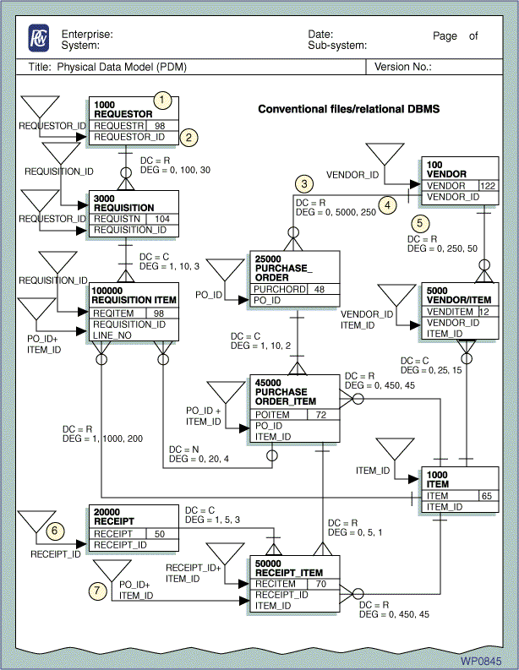

Develop Data Dictionary – (Optional)

Overview | A data dictionary, describes what is in the database and contains textual definitions of data elements and objects, as well as physical representation information (e.g., size, precision, ranges, default values, dependencies on other data elements, relationships with other data elements, and frequencies). A data dictionary can store definitions of conceptual or logical objects without regard for implementation as well as physical objects that have implementation characteristics. Definitions of non-automated data may also reside in the data dictionary.  A data dictionary can provide many benefits to an enterprise, including:  Maintenance and enforcement of standard data definitions and names by the DA. The data dictionary is the repository for standard definitions and is used to disseminate definitions to programmers, analysts, and database designers. The data dictionary also serves as a mechanism for receiving and approving definitions used by various projects.  Visibility and resolution of data redundancies in different implementation objects. The average large organization has many redundant and inconsistent definitions, names, and measuring units (e.g., pounds vs. feet) for data objects that can best be compared and resolved using the data dictionary.  Cross-referencing and reporting on where data objects are used. Where-used reports can be used for impact analysis of a proposed change to an application or data format (e.g., all modules using a particular data element can be identified). These reports can also be used to review proposed system revisions.  Systems analysis. The data dictionary stores resource information about processes (e.g., transaction volumes) and data in support of system analysis tasks.  Systems administration. The data dictionary stores information about the data processing environment including programs, job streams, and users that can be used to aid in overall systems administration.  Project management assistance in controlling the development and maintenance of applications  Database administration to assist in the design and maintenance of database structures  Communications administration. The data dictionary stores information about data processing equipment such as location and type of terminals, communications links, and CPUs.  Document control. The data dictionary can complete document tracking and control functions for specifications, user manuals, test reports, or models.  Change and configuration control. The data dictionary can track changes to applications throughout the life cycle.  Programming support through the provision of copy libraries, test data, and data language definitions.  Provide on-line help to applications users. The data dictionary can be accessed live (with appropriate levels of security) by users to display data definitions.

Approach | Define each attribute in the data model to its final level. This definition should include location, size, format, edit, and value information.  Other issues to address include:  Relative positioning within an entity where relevant (particularly for links based on foreign keys or internal sort keys)  Syntax and edit values for range limits and all non-dependent and dependent edit rules  Data type (e.g., numeric, alphabetic)  Internal storage format (e.g., binary)  Unique formats (e.g., date as yy/mm/dd or mm/dd/yy or dd/mm/yy)  Default display formats (e.g., the '/' in dates, thousands comma separators, number of display decimals)  Number of storage positions occupied  Number of decimal or binary positions for numeric elements  Whether zero suppression is to be used  Whether negative values are allowed
Work Product | In a normal data model, entities represent business concepts such as PURCHASE ORDER, EMPLOYEE, or PART. These entities have relationships with one another and they have attributes (i.e., data element definitions) describing their data content.  A data dictionary structure is similar except that the entities are system objects such as DATA ELEMENT, FILE, SCREEN, REPORT, RECORD, PROGRAM, or PROCESS. Sometimes these data dictionary entities are called meta-data entities or meta-entities.  These meta-entities have meta-relationships with one another (e.g., RECORD contains DATA ELEMENT, PROGRAM accesses RECORD, processes belong to PROGRAM). Common relationships include:  File contains record.  Record contains data element.  Data element is used by report, screen, window, transaction, program, and module. Program uses file.  Program generates report.  Program contains module.  System contains program.  Program belongs to jobstream.  A conceptual data model (CDM) of a data dictionary can be prepared showing meta-entities and meta-relationships in the same way as a data model can be prepared for a business process.  A data dictionary object (meta-entity) has meta-attributes (e.g., a DATA ELEMENT has the attributes NAME, SIZE, PRECISION, DESCRIPTION, and RANGE).  The structure of a data dictionary is defined in terms of these meta-entities, relationships, and attributes. The data dictionary stores multiple occurrences for each of these (e.g., SOCIAL SECURITY NUMBER is an occurrence of DATA ELEMENT with a SIZE of 11 and is contained in the RECORD named EMPLOYEE). Thus, the data dictionary would typically have a table for DATA ELEMENTS and another for RECORDs.

Input | "Determine the Additional Attributes Required for Personalization"  "Review Any New Content Types Required for the BroadVision Schema"

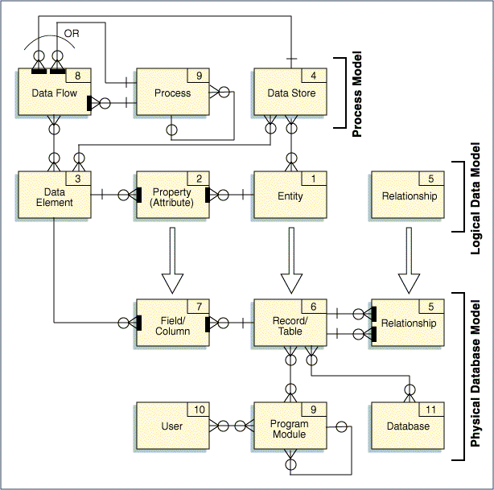

Sample Work Product

Design BroadVision Schema for External Data Sources

Overview | The BroadVision One-To-One application has the ability to access data physically stored in a remote data source. In order to access and manipulate such data, the default BroadVision schema must be altered and entities that map the data from the external data source into the BroadVision database must be created. During this task, this mapping entity is designed.

Approach | Review data model for remote data source  Review internal, BroadVision-based entity that will correspond to external data source  Identify name for mapping entity  Identify necessary attributes for mapping entity

Work Product | The typical working document is prepared and managed in an MS Excel worksheet or in an MSWord table. Typical column header’s are: Attribute, Data Type, Length, and Semantics.

Input | The above content section and business rules define the external data sources requirements.

Sample Work Product

Technical Infrastructure Overview
Submit IT Environment
Construct and Implement Development Site Networks
Construct and Implement Development Operations and Management Environment
Prepare For IT Environment Build-Out
Install and Configure IT Development Environment Components
Test IT Development Environment

Prepare IT Environment Build-out

Overview | The IT Build-out Checklist describes the steps necessary to install and configure the IT environment.

Approach | Design team creates the IT Build-out Checklist which outlines the steps that need to be performed during the installation and configuration of IT infrastructure.  Team members then follow the steps outlined in the checklist. These specifications provide the necessary information for Development Team to perform installation and configuration of IT infrastructure. After completing each step outlined in the document the responsible team member would check the corresponding item in the checklist. By the end of installation process the completely filled out and signed off check sheet would be a part of the overall deliverable.

Work Product | The IT Build-out Checklist is a document that outlines the means for safe transitioning from existing type of environmental set up to the new one. It consists of several chapters that match the chapters in Technical Infrastructure Design documentation. Each one of the chapters is subdivided into smaller steps that have to be checked off during the installation process.

Sample IT Build-out Checklist | A sample of IT Build-out Checklist is attached below:

Sample Work Product
*** DRAFT***
Small Business Services Portal Engine Project

IT Build-out Checklist

1.0 Construct and Implement Development Site Networks

___ 1.1
___ 1.2
___ 1.3

2.0 Construct and Implement Development Operations and Management Environment

___ 1.1
___ 1.2
___ 1.3

3.0 Install and Configure IT Development Environment Components

___ 1.1
___ 1.2
___ 1.3

4.0 Design Documentation for Testing IT Development Environment

___ 1.1
___ 1.2
___ 1.3

Sign-0ff

Fleet Contact | Design Signoff | Date
PwC Functional Contact | Design Signoff | Date
PwC Technical Contacts | Design Signoff | Date

Construct and Implement Development Site Networks

Overview | The purpose of this step is to construct and implement Development Site Networks required to support the operations under all environments. Construction entitles installation of physical plant, installation of physical servers, installation of network equipment, and configuration of services.

Approach | Refer to Figure 1-0 for a snapshot for network layout in version 1.0  Responsible design team members will fill up the Network Loading Matrix based on the results of network configuration. This document would outline the scope of network environment, network management issues, and physical items for network connectivity of all required system components.  The following performance is expected for WAN/Intranet:  .5 pages/minute = 25 KBpm = 200 Kbps = 3.3 Kbps  4 Tx/page = 10 KBpm = 1.3 Kbps  Total bandwidth/concurrent user = 4.6 Kbps

Work Product | Network Loading Matrix is a document that highlights the network performance between different locations. It provides such details as the bandwidth required to support peak and average demand, type of protocols used, and required response time. Loading Matrix also provides the total for peak and average demand.

Sample of Network Loading Matrix | A sample of Network Loading Matrix is attached below:

Fig 1-0: Network diagram for version 1.0
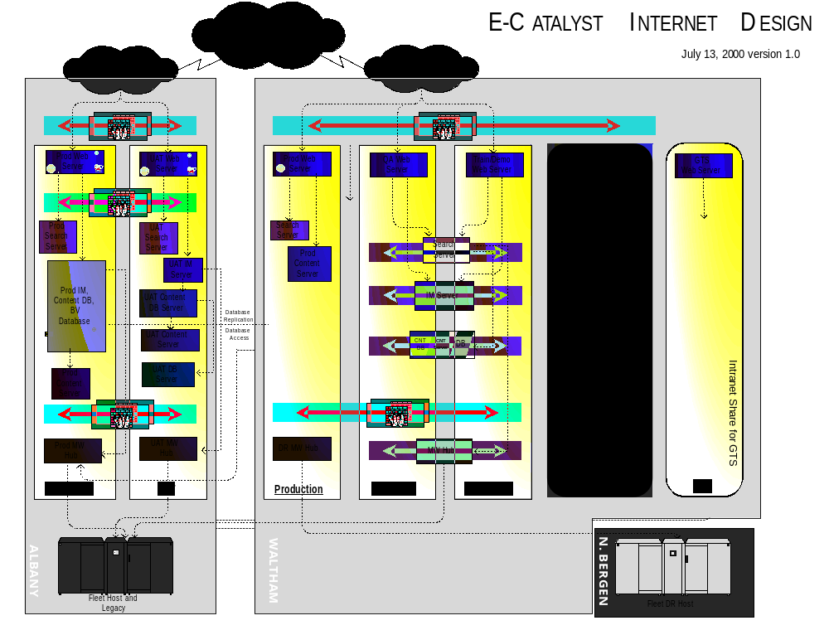

Sample Work Product
*** DRAFT***
Small Business Services Portal Engine Project

Network Loading Matrix

Location |  |  |  |  | Total
Location
Protocol(s)
Packet size
Peak/average demand
Batch/online
Async/sync
Response (seconds)
Location
Protocol(s)
Packet size
Peak/average demand
Batch/online
Async/sync
Response (seconds)
Location
Protocol(s)
Packet size
Peak/average demand
Batch/online
Async/sync
Response (seconds)
Total

Construct and Implement Development Operations and Management Environment

Overview | The purpose of this step is to install the functions and modules required to support the environment.

Approach | Environment Needs  Environments needed are as follows. Production locations are Albany and Waltham. All other environments should be determined by SMEs.  Internet production in Albany and Waltham - Full DR capability.  Intranet production in Albany and Waltham - Full DR capability.  Internet UAT– 25% capacity of production  Intranet UAT – 25% capacity of production  Internet QA/SIT/Training/Demo – 25% capacity of production  Intranet QA/SIT/Training/Demo – 25% capacity of production  Management Environments:  Systems and Network Management Environment will be integrated to BMC Patrol, Best1, and the TEC console.  Application management environments will be integrated to BMC Patrol and the TEC console.  Support tools:  The Standard Help Desk Matrix would handle help desk support;  Telecommunications Support would be handled by an Equivalent to Homelink;  LAN Support would be handled by Standard laptop/desktop support;  Backup/Restore would be done according to Standard backup procedures.  Design Team Responsibilities:  Design team members are going to fill out a Management Component Support Form. This document should act as a reference to the development operations and management environment. Its completion ensures that all the necessary management components have been installed and configured.

Work Product | Management Component Support Form is a matrix that matches applications with management components that relate to them. The rows represent application names, while the columns list various types of components that support them.

Sample Management Component Support Form | A sample Management Component Support Form is attached below:

Sample Work Product

Management Component | Processing  architecture |  |  |  |  | Hardware |  |  |  |  |  | System software |  |  |  |  |  |  | Data management |  |  |  |  | Telecom. software |  |  |  |  |  | Others
Application

Install and Configure IT Development Environment Components

Overview | The purpose of this step is to ensure that installation of IT environment components is completed in a structured manner to reduce rework and produce a high-quality product.

Approach | Servers:  - Web Server on NT running Microsoft IIS  - Search Server on NT  - Interaction Manager Server on Solaris  - Content Database Server on Solaris  - Content Server on Solaris  - BroadVision Database Server on Solaris  - Middleware Hub for version 1.0+ on AIX  The level of interaction between servers is highlighted on Figure 1-0.  Refer to attached IT Component Infrastructure document for details on environment components.  Design team members are going to fill out an IT Component Support Form. This document should act as a reference to all the development environment components for application systems. Its completion ensures that all the necessary IT components have been installed and configured.

Work Product | IT Component Support Form is a matrix that matches applications with the components that relate to them. The rows represent application names, while the columns list various types of IT components that support them.

Sample IT Component Support Form | A sample IT Component Support Form is attached below:

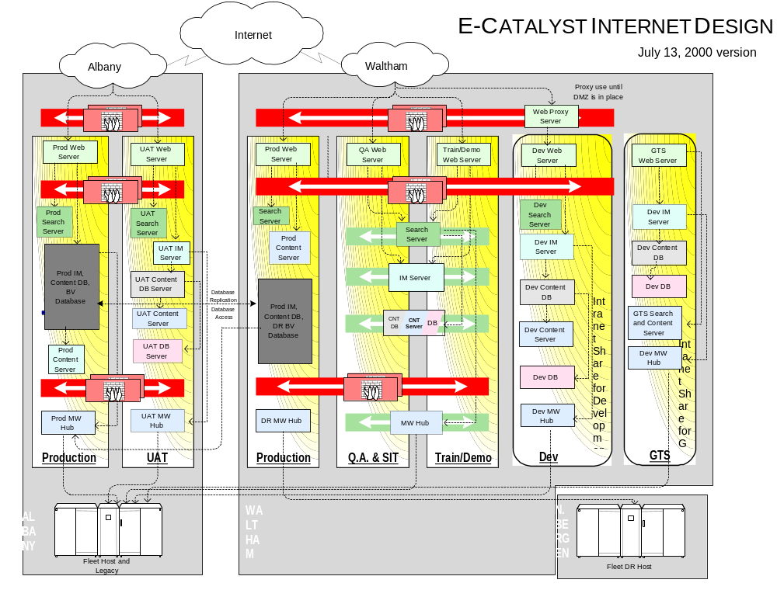

Fig 1-0: Interaction between IT components

Sample Work Product

Technology component | Processing  architecture |  |  |  |  | Hardware |  |  |  |  |  | System software |  |  |  |  |  |  | Data management |  |  |  |  | Telecom. software |  |  |  |  |  | Others
Application

Test IT Development Environment

Overview | The purpose of this step is to ensure that all the components of IT environment have been thoroughly tested and to confirm that they are working as expected.

Approach | Design team is going to complete the Development Environment Test Log Form. This document should ensure that all developers have proper access to computer facilities so that they can produce, compile and execute source code.

Work Product | Development Environment Test Log Form lists the results of test runs for all the vital components of the environment. This form lists the test-run ID, Component IDs on which the test-run was performed, date of test-run, number of times this test run was performed, tester’s name, test-run status and result. It also allocates space for problem description and problem resolution notes.

Sample Development Environment Test Log Form | A sample Development Environment Test Log Form is attached below:

Sample Work Product
This is a partial list of Tested Components to verify that the Testing Environment is ready.
Test-ID | Component-ID  and Version-NUM | Date | Iteration  ("try") | Tester  Name(s) | Status | Result
CL-RV-00-000-01 | i:\TESTLIB  \DATABILD  \PRESERVE  V.6 | 5/19/XX | 3 | B. Baker | Suspended | Not OK
Optional (If result Not OK): Describe unsatisfactory conditions
Test suspended by me for time after about 2 minutes. Trace indicates that the SQL "RSV-ADD" is source of problem.
Optional (If result Not OK): Problem Resolution
Fixed RSV-ADD by changing verb from "ADD CURRENT" to "ADD NEXT."

Submit IT Environment

Overview | The purpose of this phase is to outline all the steps necessary to walk through the installed, configured, and tested IT environment.

Approach | The design team will compile IT Environment Construction Deliverable. This document would compile documentation produced for following tasks:  - Preparation for build-out  - Construction and implementation of development site networks  - Construction and implementation of development operations and management environment  - Installation and configuration of IT development environment components  - Testing of IT development environment  Design evaluators will also make sure that all the errors, omissions, and oversights outlined in the deliverable have been corrected.

Work Product | IT Environment Construction Deliverable is a compilation of the following documents:  - IT Build-out Checklist  - Network Loading Matrix  - Management Component Support Form  - IT Component Support Form  - Development Environment Test Log Form

Technology Interface / Batch / Data Migration Design Overview
Define rerun procedures

Define translation rules for each data element
Define error identification and cleansing strategies
Define audit trails necessary for proof of running
Define reconciliation strategy
Define recovery/restart procedures

Define Translation Rules for each Data Element

Overview | This activity involves mapping data from the BroadVision database to external systems that are to be integrated with BroadVision system. Integration with external systems however is not planned for the initial release, BroadVision is being implemented out of the box with minimal or no integration.

Approach | - Determine the external data that is to be presented on the site  - Determine data fields from the BroadVision tables that will hold the data  - Establish a mapping between the two systems

Work Product | A typical work product is an MS Excel worksheet mapping each data element from its parent system (HOGAN, CMS, etc) to BroadVision’s database fields.

Sample Work Product

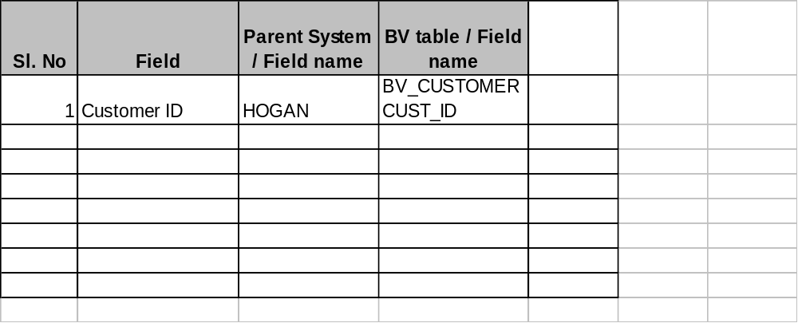

Define Error Identification and Cleansing Strategies

Overview | Errors may occur because of end-user input or some other effect in the implementation layers. This activity involves defining an identification strategy to classify errors as continuable or non-continuable and corresponding actions to undertake.

Approach | - Define and design an error page to report errors that are non-continuable  - Define a strategy to check for errors  - Define strategies to handle continuable and non-continuable errors

Work Product | Wireframe of the error page. A sample program logic depicting the error checking and handling segments of code.

Sample Work Product | Attached is a sample logic flow of a .jsp incorporating error checking and handling.

Sample Work Product
Sample Logic Flow

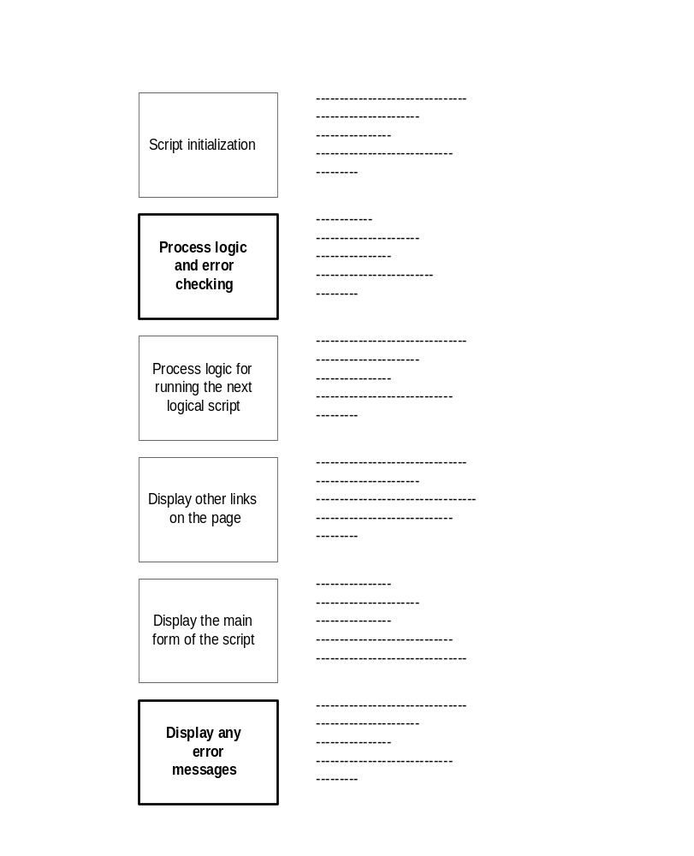

Define Audit Trails Necessary for Proof of Running

Overview | Log files may be used to track usage of the site and to monitor user behavior on the site. During this activity such log files are configured.

Approach | - Identify the kind of user activity to log  - Determine if pre-defined tracking events can be used, else design tracking events  - Configure log files

Work Product | An MS Excel spreadsheet summarizing the activity to be logged, the frequency at which it is to be logged and corresponding reports, if any is created.

Sample Work Product

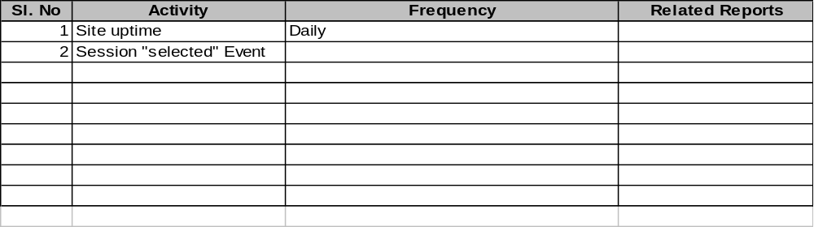

Define Reconciliation Strategy

Overview | The purpose of this process is to review log files and errors reported in them. A strategy is then drawn up to reconcile the errors, find the source of the error and develop a solution.

Approach | - Review the audit log files  - Establish a reconciliation strategy to handle errors reported in the logs

Work Product | A typical work product is an MS Word document detailing the strategy to be employed to handle errors.

Sample Work Product

Define Recovery and Restart Procedures

Overview | The purpose of this task is to establish mechanisms for disaster recovery. Mechanisms to handle failures of the web server or the Interaction Manager are designed using stop and startup routines. The Tivoli system is intended to be used to monitor and manage the production system and track disasters.

Approach | - Determine the types of disasters required to be handled  - Design stop and restart routines

Work Product | The work product is an MS Excel spreadsheet listing each routine, its location and function.

Sample Work Product

Define Recovery and Restart Procedures

Sample Worksheet

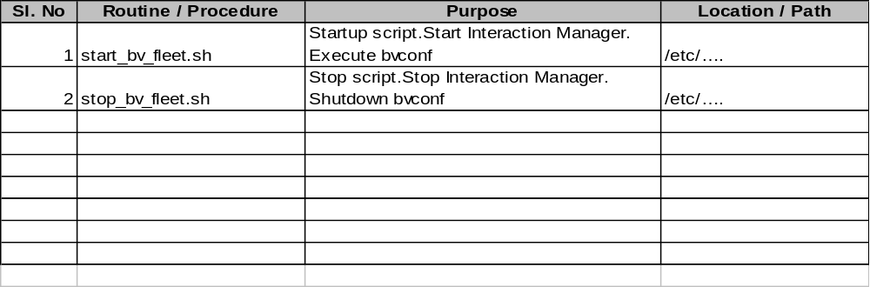

Define Rerun Procedures

Overview | The purpose of this task is to establish recovery procedures to handle disasters such as Interaction Manager or Web server failure.

Approach | - Establish “stop” scripts to shutdown Interaction Managers and the Web server  - Establish “startup” scripts to bring them up again

Work Product | The work products will be a set of stop and startup scripts.

Sample Work Product | A sample work product is attached.

Sample Work Product

Sample startup script pseudo code

Source BV variables

Execute bvconf

<check for errors>

Startup the Interaction Manager(s)

<check for errors>

Sample startup script

Source BV variables

Shutdown the Interaction Manager(s)

Execute bvconf shutdown

Reporting Design Overview
Develop pseudo code for each report

Report Design

Overview | This activity entails the review of standard reports provided by BroadVision and design of custom reports.

Approach | BroadVision provides a set of standard reports to track activities such as:  - What percentage of visitors selected a particular advertisement?  - What percentage of visitors have profiles?  - What percentage of visitors clicked an advertisement when it appeared on the bottom of a page, as opposed to the percentage that clicked it when it appeared on top?  These reports help in evaluating the site’s performance of your site and planning for optimal results.  The design of a custom report involves the following steps:  - Design of the report query  - Design of the report layout  - Configuration of the BroadVision database in order to generate the report  - Report generation

Work Product | A typical work product is the pseudo code of the report query and the report layout.

Sample Work Product

Report Design

- Define Report Parameters.
- Use SQL to create the report query.
- Design the report layout. Refer to your Microsoft Access 95 documentation for instructions.

Design Report Parameters

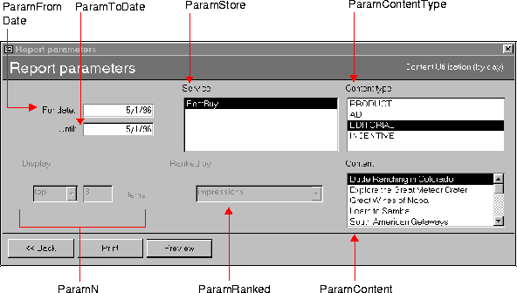

Design Custom Reports in MS Access

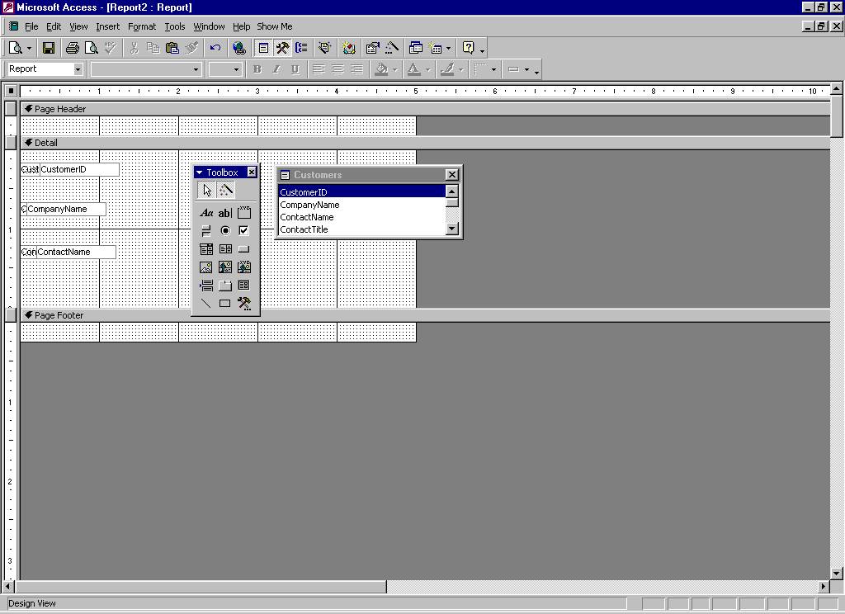

Testing Design Overview

